**PROJECT REPORT**

Submitted by

CB.EN.U4CSE19418 - Deepak L

CB.EN.U4CSE19428 - Karan M

CB.EN.U4CSE19438 - M.Bhavya sree

CB.EN.U4CSE19442 - Nanda Kishore B

CB.EN.U4CSE19457 - Suraj S P

***is partial fulfilment of the requirements for the Course – 19CSE314***

***(Software Engineering)***

**BACHELOR OF TECHNOLOGY**

**IN**

**COMPUTER SCIENCE AND ENGINEERING**



**DEPARTMENT OF COMPUTER SCIENCE AND**

**ENGINEERING**

**AMRITA SCHOOL OF ENGINEERING**

**COIMBATORE -641112**

**MAY 2022**

**AMRITA VISHWA VIDYAPEETHAM**

**AMRITA SCHOOL OF ENGINEERING, COIMBATORE**

**DEPARTMENT OF COMPUTER SCIENCE AND**

**ENGINEERING**



**BONAFIDE CERTIFICATE**

This is to certify that the report entitled “Automating elective processing.”

**Submitted by**

CB.EN.U4CSE19418 - Deepak L

CB.EN.U4CSE19428 - Karan M

CB.EN.U4CSE19438 - M.Bhavya sree

CB.EN.U4CSE19442 - Nanda Kishore B

CB.EN.U4CSE19457 - Suraj S P

is partial fulfilment of the requirements for the award of grade in

course – **19CSE314 (Software Engineering)** is a bonafide record of

the work carried out at Amrita School of Engineering, Coimbatore.

Evaluated on: 17-05-2022

Course Faculty Faculty Examiner

**TABLE OF CONTENTS**

|  |  |  |
| --- | --- | --- |
| **SNO.** | **TOPIC** | **PAGE NO.** |
| 1) | **Preview of The Project**   * Abstract * Need & Motivation * Tools and Technologies used |  |
| 2) | **Software Requirements Specifications**   * Functional and Non-Functional Requirements * User stories and Tasks flow diagram * Weekly Plan for Sprint 1 * Weekly Plan for Sprint 2 * Boundaries and Constraints |  |
| 3) | **Product Backlog**   * Report of Product Backlog from JIRA * EPIC 1: login setup * EPIC 2: Students * EPIC 3: Admin * EPIC 4: Faculty |  |
| 4) | **Diagrams**   * DFD * Use Case Diagram |  |
| 5) | **Scrum Activities**   * Sprint 1 stand-up notes * Sprint 1 retrospective notes * Burndown Chart for Sprint 1 * Sprint 2 stand up notes * Sprint 2 retrospective notes * Burndown Chart for Sprint 2 |  |
| 6) | **Implementation** |  |
| 7) | **Sample Code** |  |
| 8) | **Software Engineering Tools Used**   * Unit Testing * UI Testing |  |
| 9) | **Screenshots of Project** |  |
| 10) | **Conclusion** |  |

1. **PREVIEW OF THE PROJECT**
   1. **ABSTRACT:**

With the advancement of Technology in the last decade, the major focus has shifted from manual systems to computerized systems, where automated systems even show high efficiency. Automating elective allocation process in colleges involve filling registration forms manually, getting it signed by respective teachers and then getting the documents concerned documents acknowledged from the concerned advisors. Usually this is a very complex process to do manually and track as there are many parameters to look into like cap available for each subject and pre requisite for subjects has be obtained by student or not, but by automating it a significant amount of overhead can be reduced on the parties involved. It is also easy for the management to allocate elective for students based on their preference and cap availability. So this automating elective processing saves a lot of time.

This project aims at building a software for automating the elective processing, which will completely automate the process of allocating the elective subjects for the students in a particular semester in a university based on their preference and eligibility. The system will be web based and will have two implementations i.e., client side (students) and server side (university admin). The server-side implementation can only be accessed over the university intranet while the client side can be accessed over the intranet. The software is designed for four kinds of users namely, students, faculty, department and system admin. To ensure fairness all the details are collected from the respective parties and it is transparent as every one can track the progress at various stages.

* 1. **Need & Motivation:**

Because Amrita is one of the largest schools, keeping track of the number of tests held, their specifics, the timetable, the faculty assigned to examine the exam, and the many other administrative chores that come with it is tiresome and stressful. A programme that can help teachers and administrators with this task is constantly in demand.

* 1. **Tools and Technologies used:**
* Visual Studio Code
* Xampp
* JIRA
* Sublime text
* Selenium: UI Testing

1. **Software Requirements Specifications**

**2.1 Functional And Non-Functional Requirements**

|  |  |
| --- | --- |
| **FUNCTIONAL**  **REQUIREMENTS** | **NON-FUNCTIONAL**  **REQUIREMENTS** |
| The Software should allow the faculty, student and admin to login.  Only the admin can allocate the slots to faculty.  Only the faculty will be able to view the slots allocated by the admin to them.  Admin will be able to change allocation according to faculty convenience.  Notifications should be sent to faculty/admin about the updates. | Time for the Faculty  allocation(calculation)  The processing of each request should be done within 10 seconds.  Space and time complexity of overall code is minimized  Security Issues.  The site is responsive in nature. |

**2.2 User stories and Tasks flow diagram**

User stories

<https://karan263488.invisionapp.com/freehand/chart-Ka73q6KY>

* 1. **Weekly Plan For Sprint 1:**

|  |  |
| --- | --- |
| **WEEK** | **PLAN OF ACTION** |
| 1 | Database creation |
| 2 | Creation of UI for student portal |
| 3 | Creation of UI for faculty portal |
| 4 | Adding additional features for student and faculty |
| 5 | Checking if everything is done |

* 1. **Weekly Plan For Sprint 2:**

|  |  |
| --- | --- |
| **WEEK** | **PLAN OF ACTION** |
| 1 | Connecting all the portals to database |
| 2 | Creating UI for admin portal |
| 3 | Connecting the admin portal to database |
| 4 | Connecting the rest portals together |
| 5 | UI testing |

* 1. **Boundaries and Constraints:**
* Once the slots are allocated by admin, the faculty can't change their slots.
* One classroom can be allocated by admin to different faculty on the same day.
* While allocating the details, the faculty id and room number should already be present in the database.
* While registering new faculty, the new faculty id shouldn’t be an already existing one.
* While doing google login, the email and password should
* match the data that is already existing in the database
* While requesting to forget password/change password, the security question’s answer should match the data in the database.

1. **Product Backlog**

**3.1 Report of product backlog from JIRA for sprint 1**

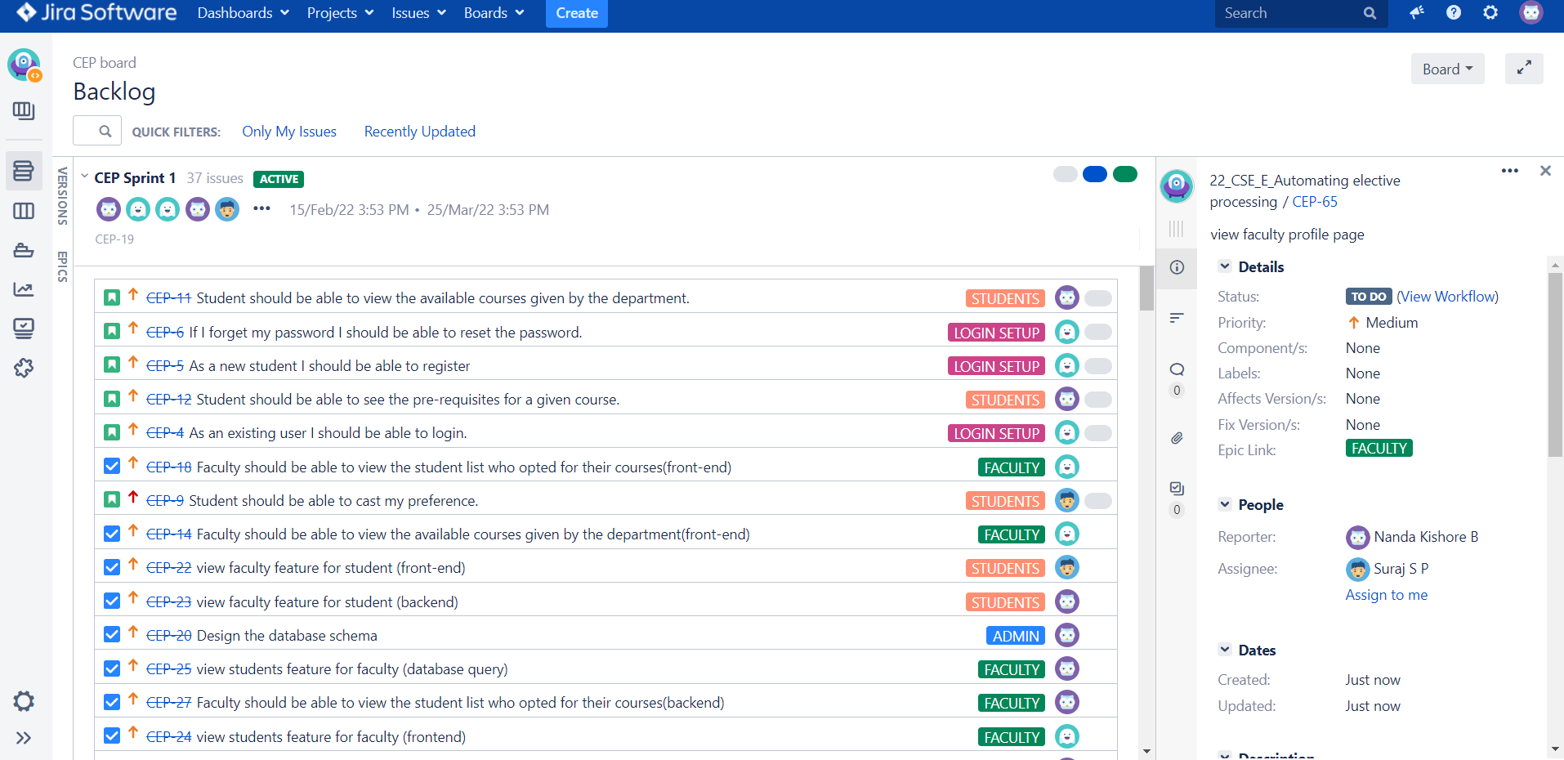

**3.2 Report of product backlog from JIRA for sprint 2**

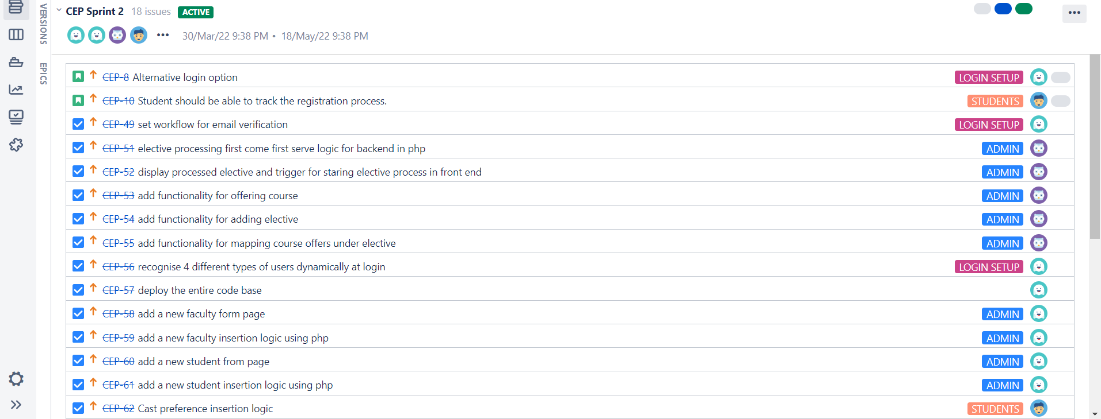

**3.2 Stories from each epic**

**3.2.1 EPIC 1 Stories:**

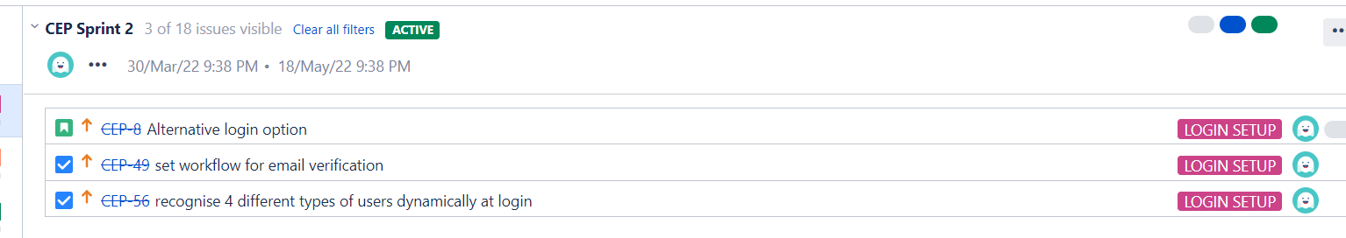

**3.2.2 EPIC 2 Stories:**

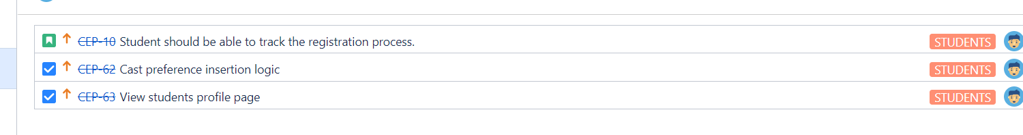

**3.2.3 EPIC 3 Stories:**

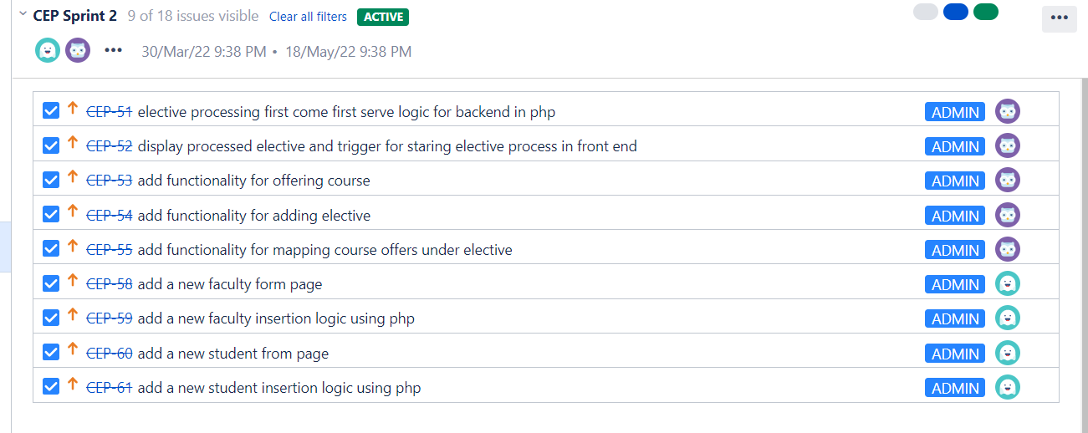

**3.2.4 EPIC 4 Stories:**

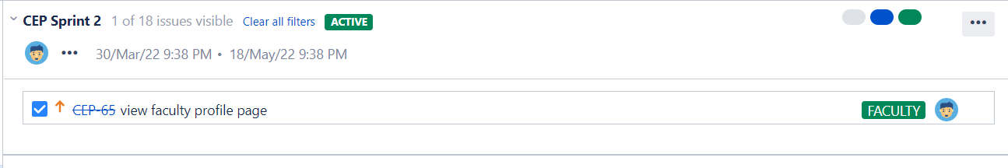

**4.Diagrams**

**4.1 Data Flow Diagram**

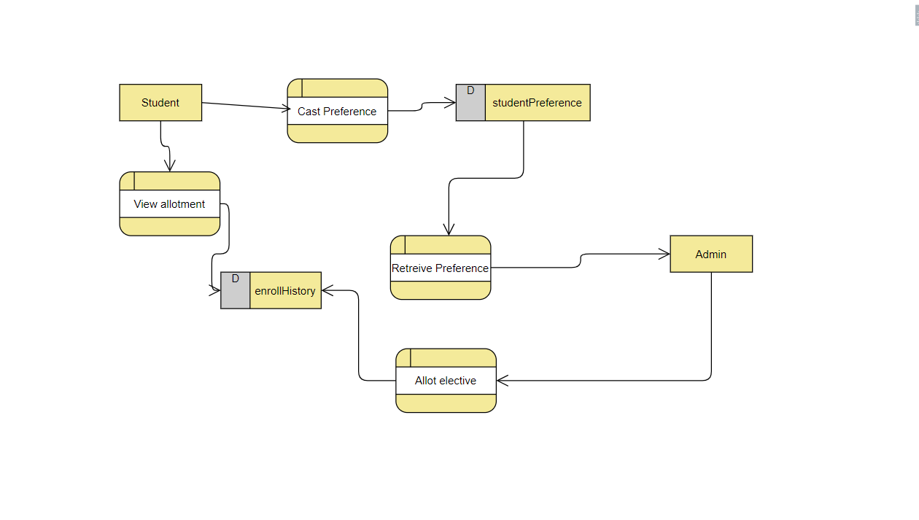

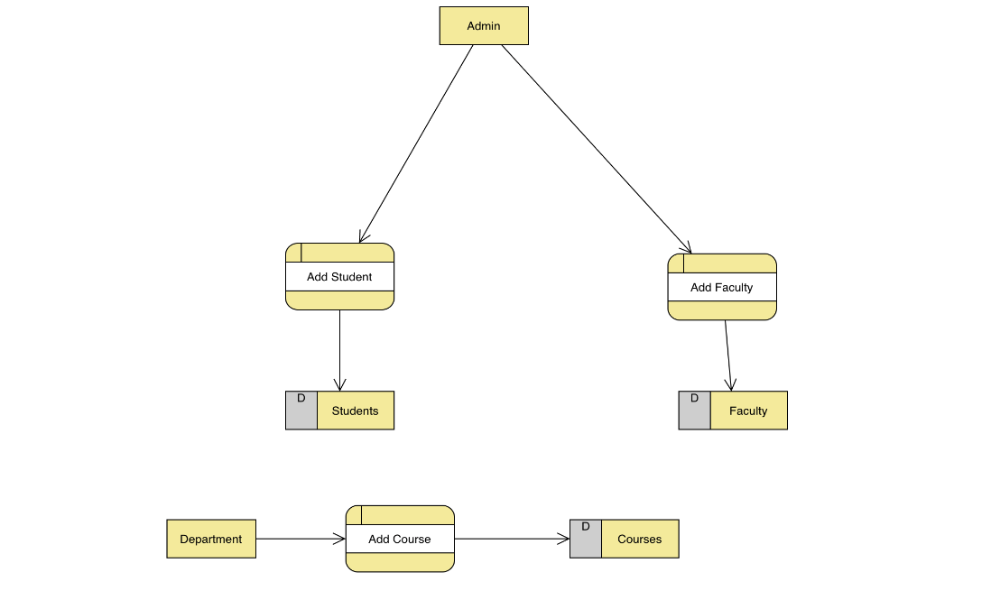

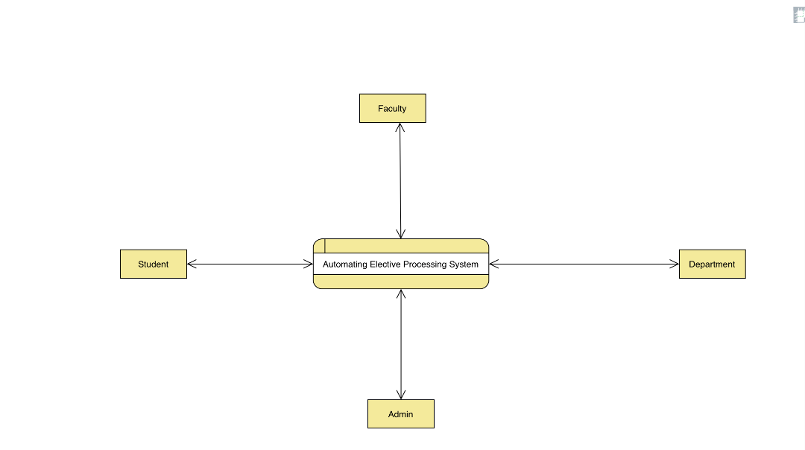

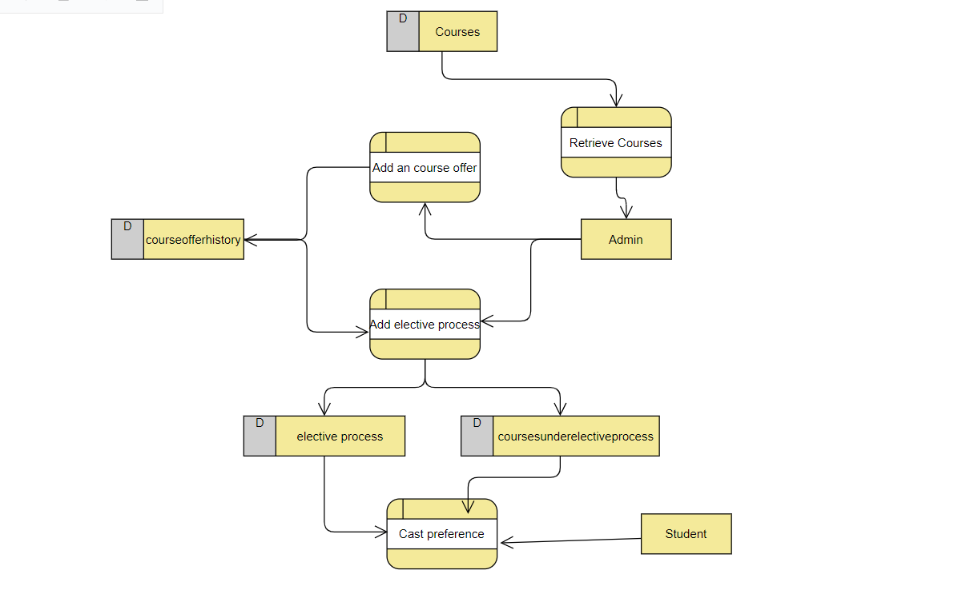

**4.2 Use Case Diagram**

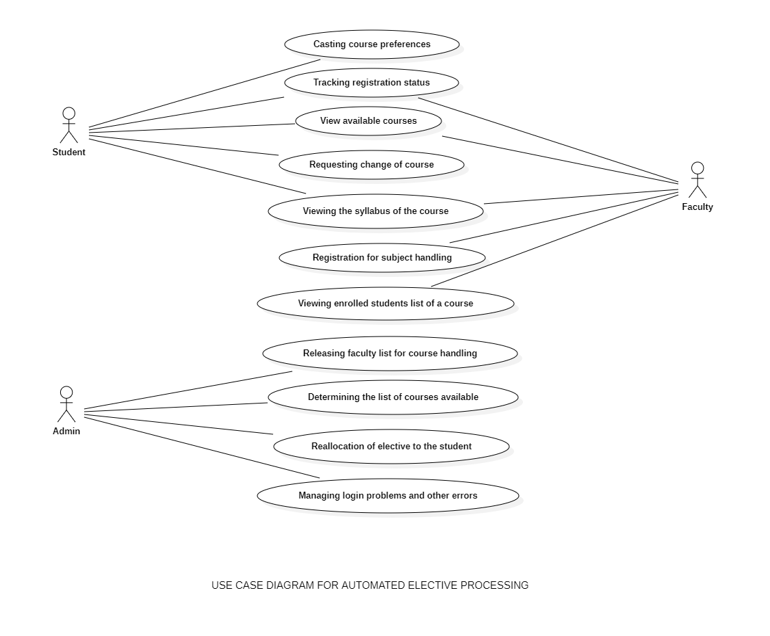

**5. Scrum activities**

**5.1 Sprint 1 stand-up notes**

We have completed all of the pics and stories that we hadplanned. We faced various errors along the road, such as database issues. During integration testing, for example, we have employed the

The issues were fixed using the available resources. As an example, we had a lot of problems with database connectivity, and we utilised resources such as to update and put data into the tables. To obtain the essential information, we used YouTube and Stack overflow. Another example is when we couldn't check whether a variable was originally empty during unit testing, so we fetched an element by id and tested the case. We later struggled with verifying alert messages and other login requirements for integrated testing, which we eventually solved utilising the available resources. Finally, trying may result in mistakes, but with dedication, we may attain the desired result.

**5.2 Sprint 1 retrospective notes:**

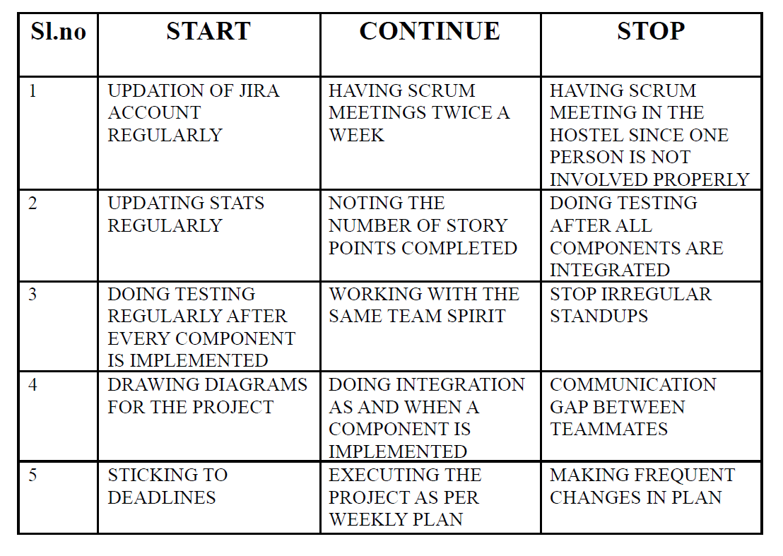

**5.3 Burndown Chart for Sprint 1:**

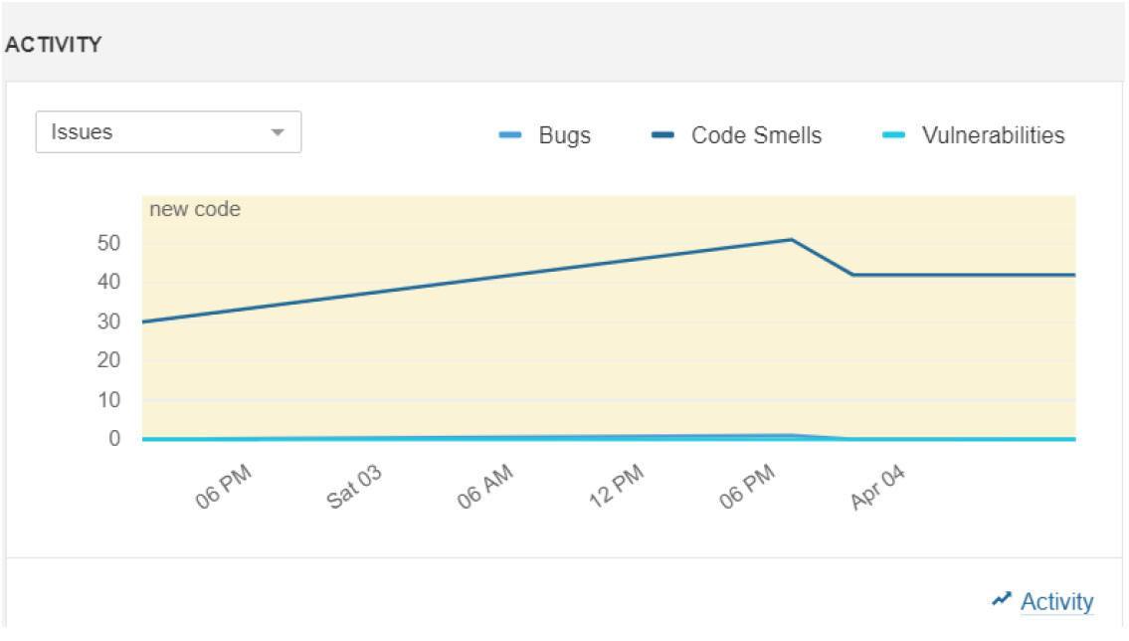

**5.4 Sprint 2 stand-up notes:**

**Karan – CB.EN.U4CSE19428**

1)

What did you do Yesterday: Null

What did you do Today: Learnt how to verify email

Are there any impediments in your way: No

2)

What did you do Yesterday: Learnt how to verify email

What did you do Today: Added the UI for verifying email

Are there any impediments in your way: No

3)

What did you do Yesterday: Added the UI for verifying email

What did you do Today: Wrote backend Code for verifying email

Are there any impediments in your way: No

4)

What did you do Yesterday: Wrote backend Code for verifying email

What did you do Today: Checked the working of verifying email

Are there any impediments in your way: No

5)

What did you do Yesterday: Checked the working of verifying email

What did you do Today: Created a Home page design

Are there any impediments in your way: No

6)

What did you do Yesterday: Created a Home page design

What did you do Today: Wrote the frontend code for home page layout

Are there any impediments in your way: No

7)

What did you do Yesterday: Wrote the frontend code for home page layout

What did you do Today: Wrote the frontend code for accessing the functionalities

Are there any impediments in your way: No

8)

What did you do Yesterday: Wrote the frontend code for accessing the functionalities

What did you do Today: Learnt about Cloud and the tools required

Are there any impediments in your way: No

9)

What did you do Yesterday: Learnt about Cloud and the tools required

What did you do Today: Learnt how to deploy the software

Are there any impediments in your way: No

10)

What did you do Yesterday: Learnt how to deploy the software

What did you do Today: Deployed the Software

Are there any impediments in your way: No

**Suraj – CB.EN.U4CSE19457**

1)

What did you do Yesterday: Null

What did you do Today: Revised SQL concepts

Are there any impediments in your way: No

2)

What did you do Yesterday: Revised SQL concepts

What did you do Today: Wrote queries for form

Are there any impediments in your way: No

3)

What did you do Yesterday: Wrote queries for form

What did you do Today: Learnt to dynamically loading the form

Are there any impediments in your way: No

4)

What did you do Yesterday: Learnt to dynamically loading the form

What did you do Today: Wrote Front-end code to dynamically load the elective form

Are there any impediments in your way: No

5)

What did you do Yesterday: Wrote Front-end code to dynamically load the elective form

What did you do Today: Wrote Back-end code to dynamically get the values from the elective form

Are there any impediments in your way: No

6)

What did you do Yesterday: Wrote Back-end code to dynamically get the values from the elective form

What did you do Today: Wrote the frontend code for getting the courses of particular elective

Are there any impediments in your way: No

7)

What did you do Yesterday: Wrote the frontend code for getting the courses of particular elective

What did you do Today: Wrote the backend code for getting the courses of particular elective

Are there any impediments in your way: No

8)

What did you do Yesterday: Wrote the backend code for getting the courses of particular elective

What did you do Today: Wrote the backend code for form Validation

Are there any impediments in your way: No

9)

What did you do Yesterday: Wrote the backend code for form Validation

What did you do Today: Wrote the backend code for checking the duplicancy of the form

Are there any impediments in your way: No

10)

What did you do Yesterday: Wrote the backend code for checking the duplicancy of the form

What did you do Today: Checked the working of the form

Are there any impediments in your way: No

**Bhavya sree – CB.EN.U4CSE19438**

1)

What did you do yesterday? Wrote the CSS code for the faculty page form

What will you do today? Wrote the HTML code for the faculty

Are there any impediments in the way? Got some minimal errors in syntax but cleared them soon.

2)

What did you do yesterday? Wrote the PHP code to connect to the database.

What will you do today Successfully receiving data through the forms

Are there any impediments in the way? No

3)

What did you do yesterday? Restructured the faculty database in the backend

What will you do today? Discuss it with the group members and make necessary changes

Are there any impediments in the way? No

4)

What did you do yesterday? Discussed the form with the members

What will you do today? Making the necessary changes in my work

Are there any impediments in the way? No

5)

What did you do yesterday? Discussed about making alterations in the database structures

What will you do today? Came up with some ideas for alteration of the database

Are there any impediments in the way? Problems in implementing the code

6)

What did you do yesterday? Wrote the CSS code for form for Student details

What will you do today? Writing the HTML code for the form to connect it to the data base

Are there any impediments in the way? Had minor errors and warnings during execution

7)

What did you do yesterday? Solving the errors in the code for form to get the student details

What will you do today? Successful completion of the HTML and CSS design structure

Are there any impediments in the way? No

8)

What did you do yesterday? Wrote the PHP code for connecting the form to the database.

What will you do today? Successfully receiving data from the form into the database.

Are there any impediments in the way? Some errors in the names of the fields.

9)

What did you do yesterday? Restructured the student database

What will you do today? Discussing with the team about the database structure

Are there any impediments in the way? No

10)

What did you do yesterday? Discussed with the team about the design of the program.

What will you do today? Suggested some changes to be made in the design.

Are there any impediments in the way? No

**Nanda Kishore B - CB.EN.U4CSE19442**

1)

What did you do yesterday? -  
What will you do today? I will do the add course offer front end page  
Are there any impediments in the way? -

2)

What did you do yesterday? I completed the add course offer front end page  
What will you do today? I will now incorporate the backend part  
Are there any impediments in the way? No

3)

What did you do yesterday? I completed the add course backend part  
What will you do today? I will do unit testing of this module  
Are there any impediments in the way? No

4)

What did you do yesterday? I completed the unit testing and added the constraints check  
What will you do today? I will do the front end part of adding elective offer  
Are there any impediments in the way? Yes, there were few missing constraints discovered in unit test, which i will add

5)

What did you do yesterday? I added the elective offer front end page  
What will you do today? I will incorporate the backend part as well  
Are there any impediments in the way? No

6)

What did you do yesterday? I completed the backend part for adding elective offer  
What will you do today? I will design the layout for elective processing  
Are there any impediments in the way? No

7)

What did you do yesterday? I completed the front end design part of elective processing  
What will you do today? I do the logic for displaying already processed electives  
Are there any impediments in the way? No

8)

What did you do yesterday? I completed the logic for displaying allotted electives  
What will you do today? I will start doing the allot elective backend  
Are there any impediments in the way? No

9)

What did you do yesterday? I made good progress in allotting elective  
What will you do today? I complete the full elective allotment algorithm  
Are there any impediments in the way? No

10)

What did you do yesterday? Completed the full module of elective processing  
What will you do today? Will do unit testing  
Are there any impediments in the way? No

**5.6 Sprint 2 retrospective notes:**

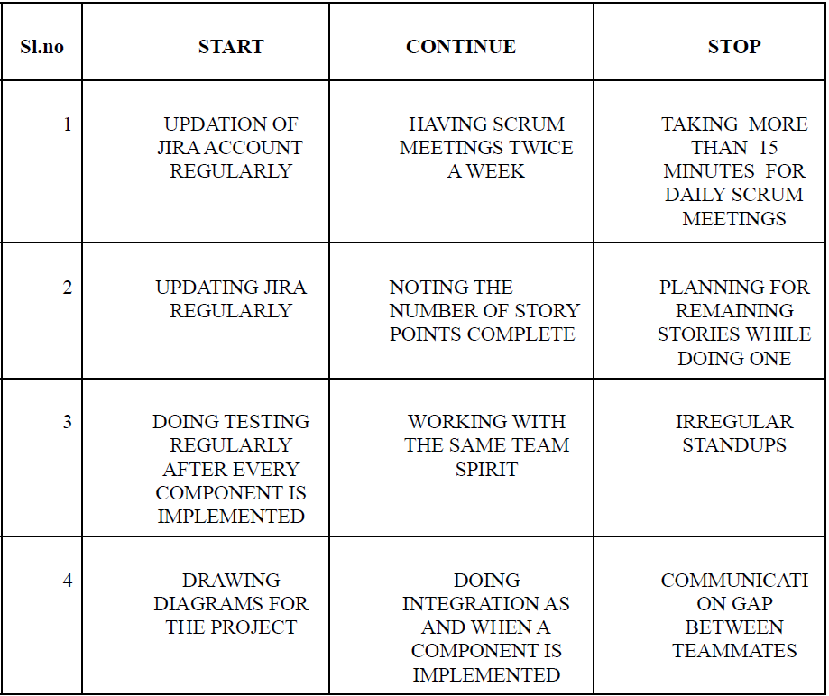

**5.7 Burndown chart for sprint 2:**

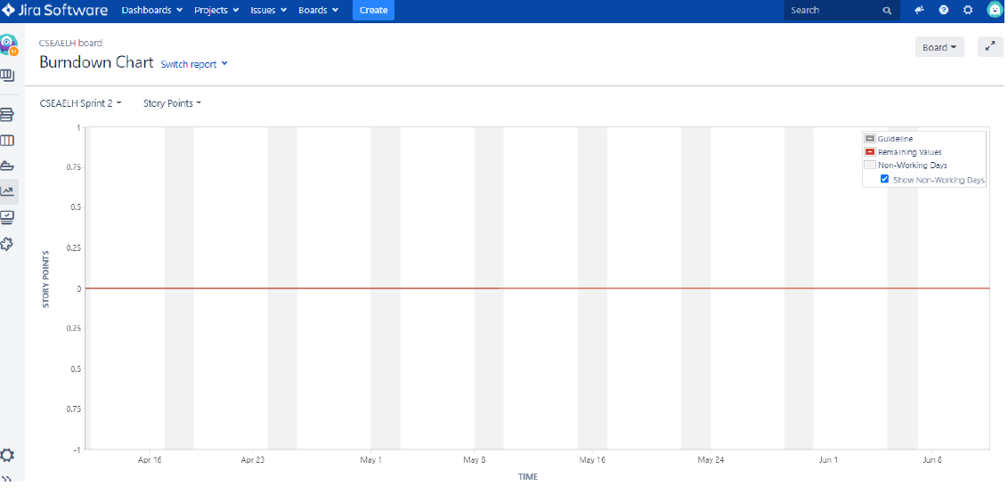

**6. Implementation**

The backend of our project is implemented using XAMPP. It is a platform that provides a suitable environment for testing and verifying the functionality of projects based on Apache, Perl, MySQL, and PHP using the host's system. Before publishing a website or client to the main server, XAMPP allows a local host or server to test it on computers and laptops. The frontend is done with the help of HTML, CSS, Java script and PHP. For a group reference and a quick one, we used the GITHUB repository so that the team members can refer the data without any problem. Selenium tool is used for testing the UI. Selenium automates web browser interaction by writing test scripts to perform various user activities on a web application's user interface. Selenium is ideal for UI testing as well as cross-browser testing since it can run the same tests on multiple browsers and versions. All the codes were run and tested in Visual studio code. We updated all our works tasks and functions carried out in the JIRA software.

**7. SAMPLE CODE**

<?php

include '../config.php';

session_start();

//error_reporting(0);

ini_set('display_errors', '1');

ini_set('display_startup_errors', '1');

error_reporting(E_ALL);

?>

<?php

  if(isset($_POST['submit']))

  {

    $course = $_POST['ChooseCourse'];

    $faculty = $_POST['Faculty'];

    $year = $_POST['year'];

    $sem = $_POST['sem'];

    $cap = $_POST['cap'];

    $offername = $_POST['offername'];

    $sql_insert =

      "INSERT INTO CourseOfferHistory(offerName,courseId,year,semester,facultyId,studentCap)

          VALUES ('$offername','$course','$year','$sem','$faculty','$cap')";

        if(mysqli_query($conn,$sql_insert))

      {

          echo '<script>alert("Course offer added sucessfully")</script>';

      }

      else{

        echo '<script>alert("Some trouble")</script>';

      }

  }

?>

<!DOCTYPE html>

<html>

<head>

<meta name="viewport" content="width=device-width, initial-scale=1">

<style>

  input[type=text], select {

  width: 50%;

  padding: 12px 20px;

  margin: 8px 0;

  display: inline-block;

  border: 1px solid #ccc;

  border-radius: 4px;

  box-sizing: border-box;

}

input[type=number], select {

  width: 50%;

  padding: 12px 20px;

  margin: 8px 0;

  display: inline-block;

  border: 1px solid #ccc;

  border-radius: 4px;

  box-sizing: border-box;

}

input[type=submit] {

  width: 50%;

  background-color: #4CAF50;

  color: white;

  padding: 14px 20px;

  margin: 8px 0;

  border: none;

  border-radius: 4px;

  cursor: pointer;

}

input[type=submit]:hover {

  background-color: #45a049;

}

  * {box-sizing: border-box;}

  body {font-family: Verdana, sans-serif; min-height: 100ch; border-block-end: 20px solid #A2133B;}

  body

  {

    margin: 0;

    font-family: Arial, Helvetica, sans-serif;

  }

  .topnav {

    overflow: hidden;

    background-color: #A2133B;

  }

  .topnav a {

    float: left;

    color: #f2f2f2;

    text-align: center;

    padding: 22px 75px 22px 75px;

    text-decoration: none;

    font-size: 17px;

  }

  .topnav a:hover {

    background-color: #ddd;

    color: black;

  }

  .topnav a.active {

    background-color: #04AA6D;

    color: white;

  }

  .topnav-right {

    padding-top: 20px;

    float: right;

  }

  table {

    border-collapse: collapse;

    width: 100%;

    color: black;

    font-family: 'PT Sans', sans-serif;

    font-size: 25px;

    text-align: left;

    }

    th {

    background-color: #a2133b;

    color: white;

    }

    tr:nth-child(even) {background-color: #f2f2f2}

</style>

</head>

<body>

<div class="topnav">

  <a href="../admin_home.php"><img src="img/amritalogo.svg" style="height:70px ; width:500px;"></a>

  <div class="topnav-right">

  <a href="../admin_home.php">Home</a>

  <a href="https://amrita.edu/about/">About us</a>

  <a href="../logout.php">logout</a>

</div>

</div>

<center>

<br><br><br>

<form method="POST">

  <label>Select a Course to offer</label>

  <select name="ChooseCourse">

  <?php

    $sql = "SELECT courseId, courseName FROM Courses";

    $result = mysqli_query($conn,$sql);

    while($row=$result->fetch_assoc()) {

      echo '<option value="' .$row["courseId"].  '">'. $row["courseName"] .'</option>';

      }

  ?>

  </select>

  <br>

  <label>Offer Name</label>

  <input type="text" name="offername" required><br>

  <label>Year</label>

  <input type="number" min="1990" max="3000" name="year" required><br>

  <label>Semester</label>

  <input type="number" min="1" max="10" name="sem" required><br>

  <label>Student Cap</label>

  <input type="number" min="0" max="1000" name="cap" required><br>

  <label>Select Faculty Handling</label>

  <select name="Faculty">

  <?php

    $sql = "SELECT facultyId, facultyName FROM Faculty";

    $result = mysqli_query($conn,$sql);

    while($row=$result->fetch_assoc()) {

      echo '<option value="' .$row["facultyId"].  '">'. $row["facultyName"] .'</option>';

      }

  ?>

  </select><br>

  <input type="submit" value="submit" name="submit">

</form>

<br>

</body>

</html>

**8. Software Engineering tools used**

**8.1 Unit Testing**

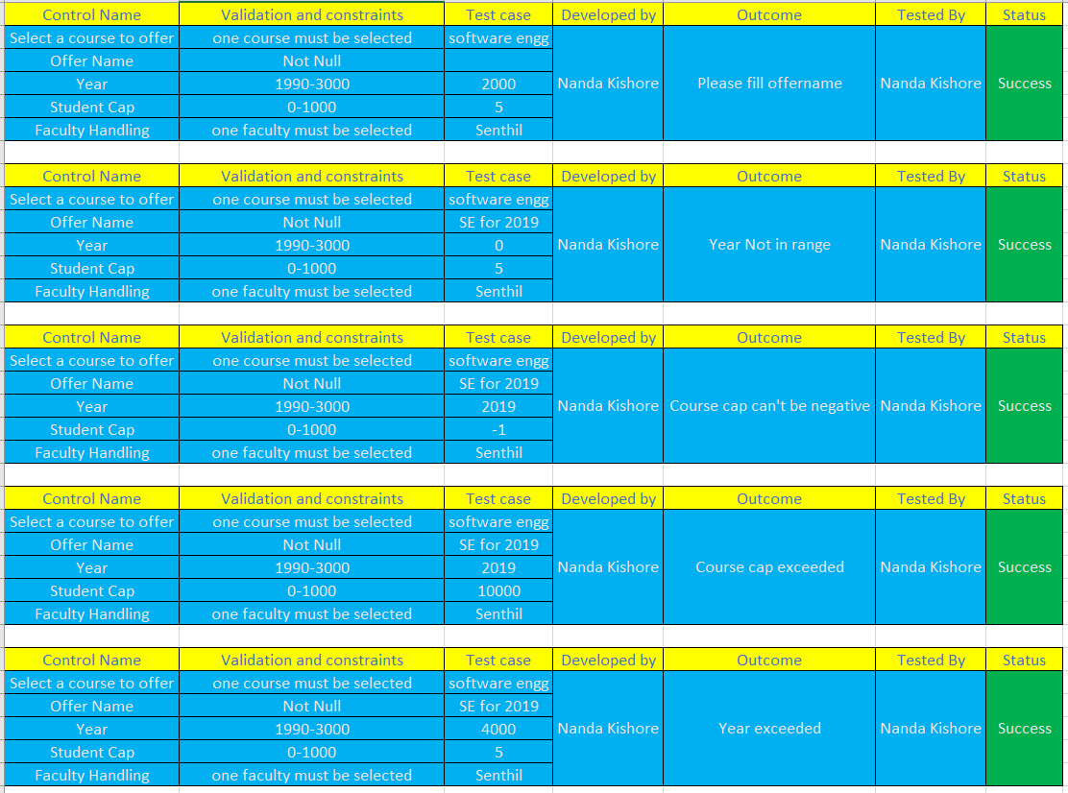

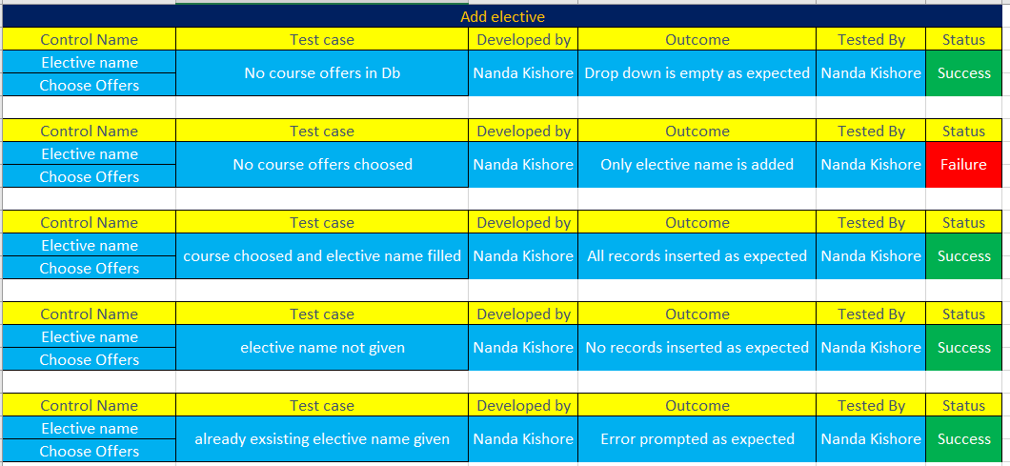

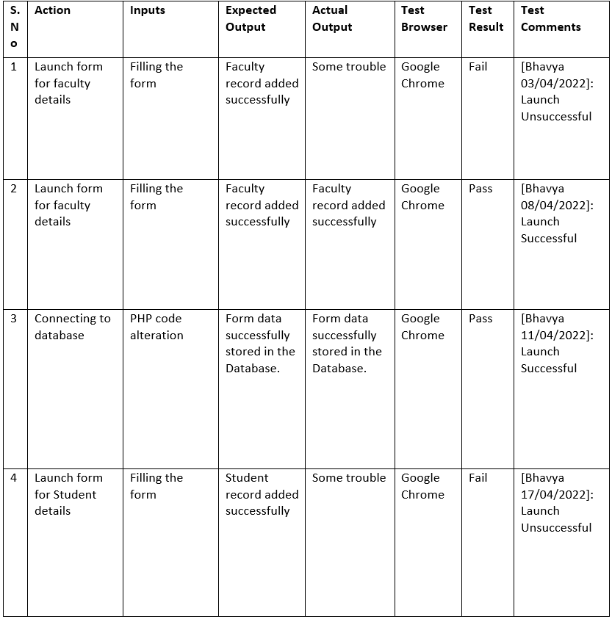

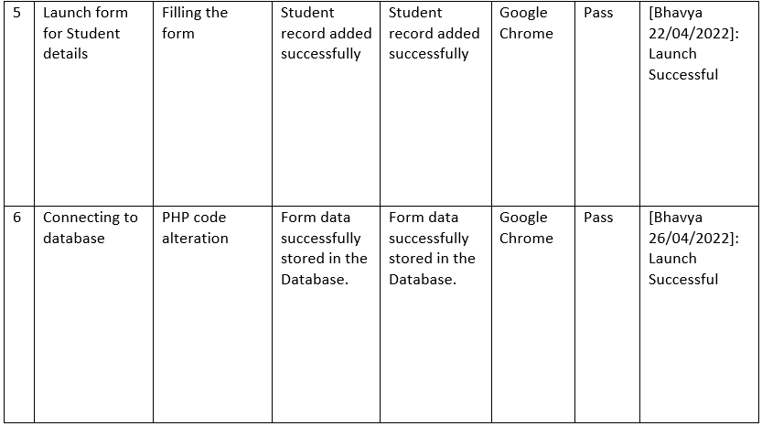

**8.1.1 Tool used and its setup details**

We have used Selenium for UI testing.

**8.1.2 Test cases code**

import static com.kms.katalon.core.checkpoint.CheckpointFactory.findCheckpoint

import static com.kms.katalon.core.testcase.TestCaseFactory.findTestCase

import static com.kms.katalon.core.testdata.TestDataFactory.findTestData

import static com.kms.katalon.core.testobject.ObjectRepository.findTestObject

import static com.kms.katalon.core.testobject.ObjectRepository.findWindowsObject

import com.kms.katalon.core.checkpoint.Checkpoint as Checkpoint

import com.kms.katalon.core.cucumber.keyword.CucumberBuiltinKeywords as CucumberKW

import com.kms.katalon.core.mobile.keyword.MobileBuiltInKeywords as Mobile

import com.kms.katalon.core.model.FailureHandling as FailureHandling

import com.kms.katalon.core.testcase.TestCase as TestCase

import com.kms.katalon.core.testdata.TestData as TestData

import com.kms.katalon.core.testng.keyword.TestNGBuiltinKeywords as TestNGKW

import com.kms.katalon.core.testobject.TestObject as TestObject

import com.kms.katalon.core.webservice.keyword.WSBuiltInKeywords as WS

import com.kms.katalon.core.webui.keyword.WebUiBuiltInKeywords as WebUI

import com.kms.katalon.core.windows.keyword.WindowsBuiltinKeywords as Windows

import internal.GlobalVariable as GlobalVariable

import org.openqa.selenium.Keys as Keys

WebUI.openBrowser('')

WebUI.navigateToUrl('http://www.electiveprocessor.epizy.com/?i=1')

WebUI.click(findTestObject('Object Repository/log in/Page_/a_login'))

WebUI.click(findTestObject('Object Repository/log in/Page_Login page/input_Sign in_susername'))

WebUI.click(findTestObject('Object Repository/log in/Page_Login page/input_Sign in_signin'))

WebUI.setText(findTestObject('Object Repository/log in/Page_Login page/input_Sign in_susername'), 'iukyjthgdfvsff')

WebUI.click(findTestObject('Object Repository/log in/Page_Login page/input_Sign in_signin'))

WebUI.setEncryptedText(findTestObject('Object Repository/log in/Page_Login page/input_Sign in_password'), 'AwMrbH+Jadw=')

WebUI.click(findTestObject('Object Repository/log in/Page_Login page/input_Sign in_signin'))

WebUI.setText(findTestObject('Object Repository/log in/Page_Login page/input_Sign in_susername'), 'cb.1001')

WebUI.setEncryptedText(findTestObject('Object Repository/log in/Page_Login page/input_Sign in_password'), 'tzH6RvlfSTg=')

WebUI.click(findTestObject('Object Repository/log in/Page_Login page/input_Sign in_signin'))

WebUI.closeBrowser()

import static com.kms.katalon.core.checkpoint.CheckpointFactory.findCheckpoint

import static com.kms.katalon.core.testcase.TestCaseFactory.findTestCase

import static com.kms.katalon.core.testdata.TestDataFactory.findTestData

import static com.kms.katalon.core.testobject.ObjectRepository.findTestObject

import static com.kms.katalon.core.testobject.ObjectRepository.findWindowsObject

import com.kms.katalon.core.checkpoint.Checkpoint as Checkpoint

import com.kms.katalon.core.cucumber.keyword.CucumberBuiltinKeywords as CucumberKW

import com.kms.katalon.core.mobile.keyword.MobileBuiltInKeywords as Mobile

import com.kms.katalon.core.model.FailureHandling as FailureHandling

import com.kms.katalon.core.testcase.TestCase as TestCase

import com.kms.katalon.core.testdata.TestData as TestData

import com.kms.katalon.core.testng.keyword.TestNGBuiltinKeywords as TestNGKW

import com.kms.katalon.core.testobject.TestObject as TestObject

import com.kms.katalon.core.webservice.keyword.WSBuiltInKeywords as WS

import com.kms.katalon.core.webui.keyword.WebUiBuiltInKeywords as WebUI

import com.kms.katalon.core.windows.keyword.WindowsBuiltinKeywords as Windows

import internal.GlobalVariable as GlobalVariable

import org.openqa.selenium.Keys as Keys

WebUI.openBrowser('')

WebUI.navigateToUrl('http://www.electiveprocessor.epizy.com/?i=1')

WebUI.click(findTestObject('Object Repository/home/Page_/a_login'))

WebUI.click(findTestObject('Object Repository/home/Page_Login page/button_Sign up'))

WebUI.setText(findTestObject('Object Repository/home/Page_Login page/input_Sign up_username'), 'deepak01')

WebUI.setText(findTestObject('Object Repository/home/Page_Login page/input_Sign up_signup_email'), 'cb.en.u4cse19418@cb.students.amrita.edu')

WebUI.setEncryptedText(findTestObject('Object Repository/home/Page_Login page/input_Sign up_signup_password'), 'iGDxf8hSRT4=')

WebUI.setEncryptedText(findTestObject('Object Repository/home/Page_Login page/input_Sign up_signup_cpassword'), 'iGDxf8hSRT4=')

WebUI.click(findTestObject('Object Repository/home/Page_Login page/input_Sign up_signup'))

WebUI.click(findTestObject('Object Repository/home/Page_Email Verification/i_Email Verification_fa-solid fa-key'))

WebUI.setText(findTestObject('Object Repository/home/Page_Email Verification/input_Email Verification_verification_code'),

'291210')

WebUI.click(findTestObject('Object Repository/home/Page_Email Verification/input_Email Verification_verify_email'))

WebUI.setText(findTestObject('Object Repository/home/Page_Login page/input_Sign in_susername'), 'deepak01')

WebUI.setEncryptedText(findTestObject('Object Repository/home/Page_Login page/input_Sign in_password'), 'iGDxf8hSRT4=')

WebUI.click(findTestObject('Object Repository/home/Page_Login page/input_Sign in_signin'))

WebUI.setText(findTestObject('Object Repository/home/Page_Login page/input_Sign in_susername'), 'deepak01')

WebUI.setEncryptedText(findTestObject('Object Repository/home/Page_Login page/input_Sign in_password'), 'iGDxf8hSRT4=')

WebUI.click(findTestObject('Object Repository/home/Page_Login page/input_Sign in_signin'))

WebUI.click(findTestObject('Object Repository/home/Page_Login page/button_Sign up'))

WebUI.click(findTestObject('Object Repository/home/Page_Login page/input_Sign up_username'))

WebUI.closeBrowser()

WebUI.openBrowser('')

WebUI.navigateToUrl('http://www.electiveprocessor.epizy.com/?i=1')

WebUI.click(findTestObject('Object Repository/home/Page_/a_login'))

WebUI.setText(findTestObject('Object Repository/home/Page_Login page/input_Sign in_susername'), 'cb.1001')

WebUI.setEncryptedText(findTestObject('Object Repository/home/Page_Login page/input_Sign in_password'), 'tzH6RvlfSTg=')

WebUI.click(findTestObject('Object Repository/home/Page_Login page/input_Sign in_signin'))

WebUI.click(findTestObject('Object Repository/home/Page_/a_View Profile'))

WebUI.click(findTestObject('Object Repository/home/Page_Student Profile Page/a_Home'))

WebUI.closeBrowser()

**Screenshots/report of the scanning results**

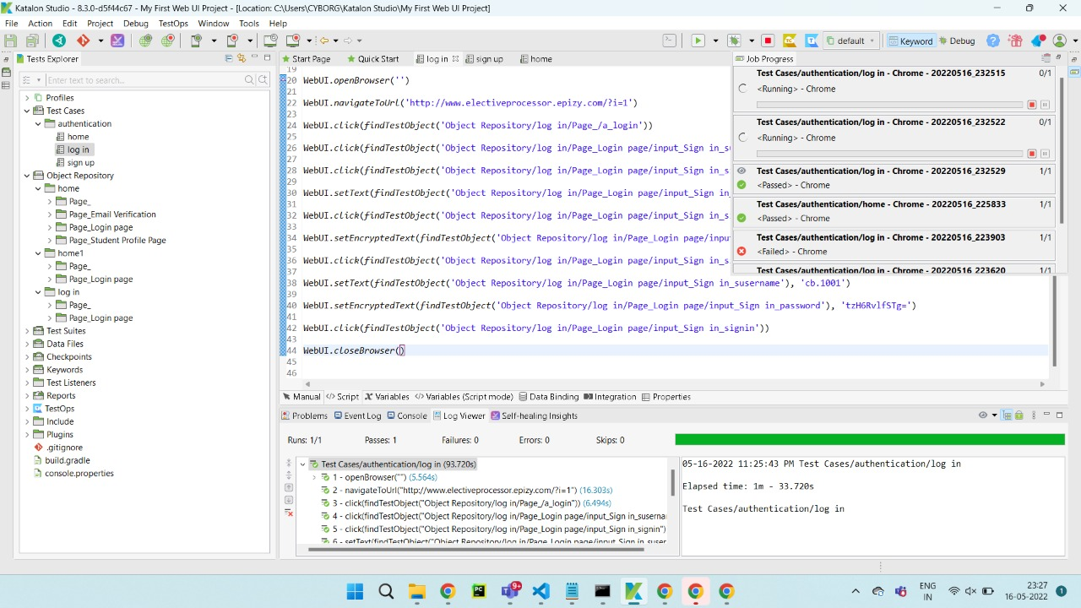

**TESTING STRATEGY:**

The testing strategy we have employed in our project as part of first sprint is:

1)Unit testing

2) Integration testing

**8.3 UI Testing**

**8.3.1 Test case code**

<?php

use \PHPUnit\Framework\TestCase;

use \PHPUnit\DbUnit\TestCaseTrait;

class MyGuestbookTest extends \PHPUnit\Framework\TestCase

{

// use PHPUnit\DbUnit\TestCaseTrait;

/**

* @return PHPUnit_Extensions_Database_DB_IDatabaseConnection

*/

public function getConnection()

{

// $pdo = new PDO("mysql:host=localhost;dbname=dbusername", 'root', '');

// return $this->createDefaultDBConnection($pdo);

// return $pdo->setAttribute(PDO::ATTR_ERRMODE, PDO::ERRMODE_EXCEPTION);

$servername = "localhost";

$username = "root";

$password = "";

try {

$conn = new PDO("mysql:host=$servername;dbname=dbusername", $username, $password);

// set the PDO error mode to exception

$conn->setAttribute(PDO::ATTR_ERRMODE, PDO::ERRMODE_EXCEPTION);

echo "Connected successfully";

return $conn;

} catch(PDOException $e) {

echo "Connection failed: " . $e->getMessage();

}

}

/**

* @return PHPUnit_Extensions_Database_DataSet_IDataSet

*/

public function getDataSet()

{

// return $this->createFlatXMLDataSet(dirname(_FILE_).'/_files/guestbook-seed.xml');

}

public function testAddEntry()

{

// $this->assertEquals(0, $this->getConnection()->getRowCount('users'), "Pre-Condition");

$nRows = $this->getConnection()->query('select count(*) from users')->fetchColumn();

$this->assertEquals(0, $nRows);

// $guestbook = new Guestbook();

// $guestbook->addEntry("suzy", "Hello world!");

// $this->assertEquals(3, $this->getConnection()->getRowCount('users'), "Inserting failed");

}

}

?>

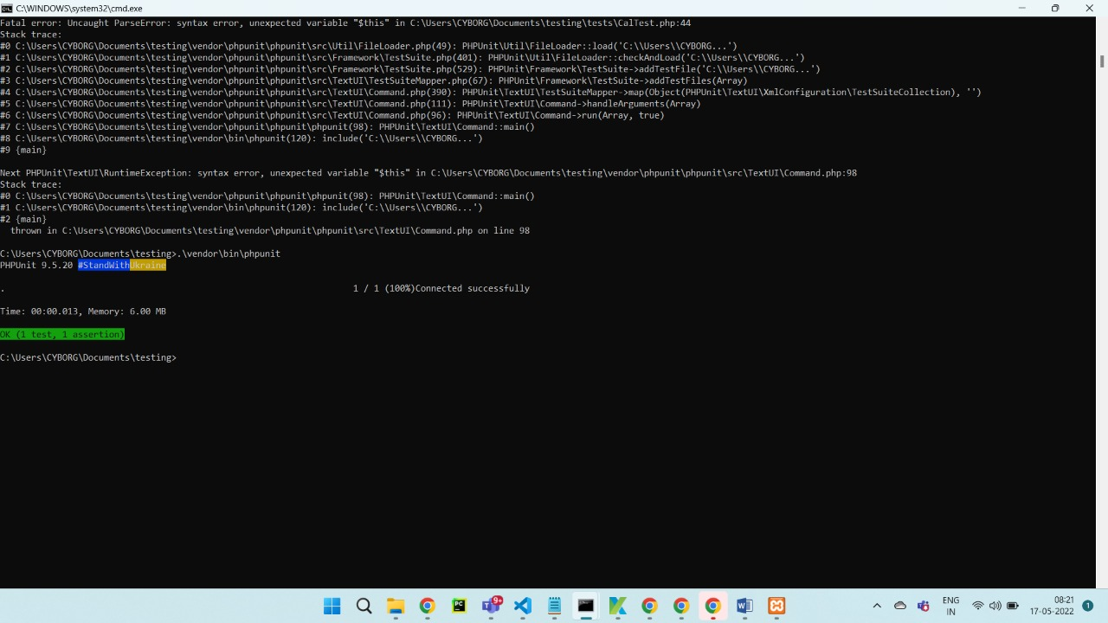

**9. Screenshots of the project**

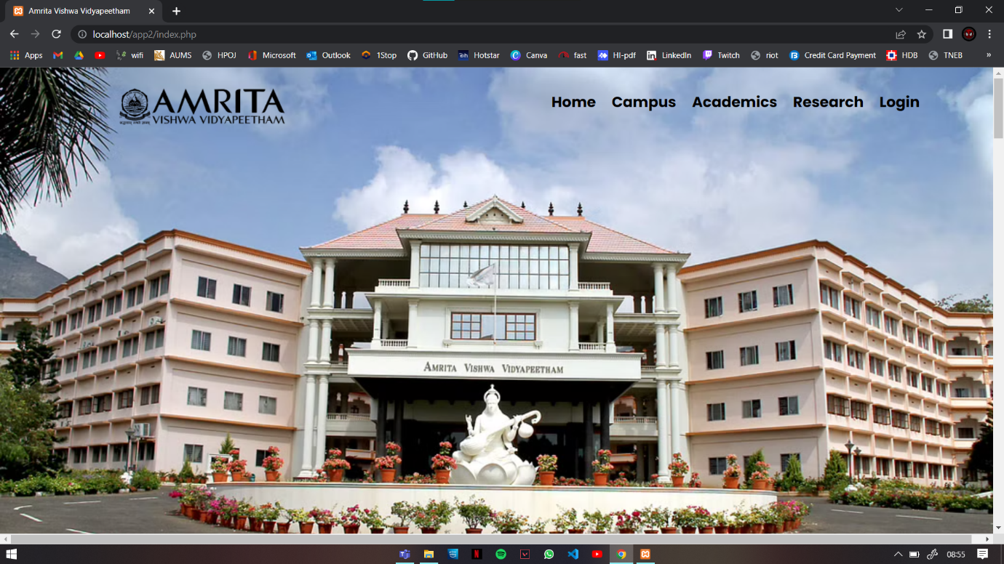

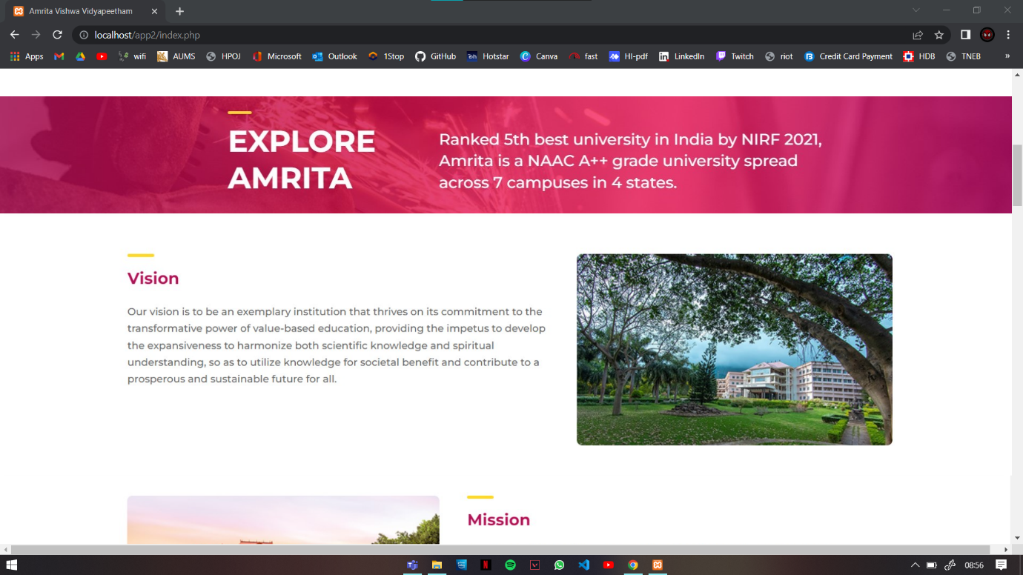

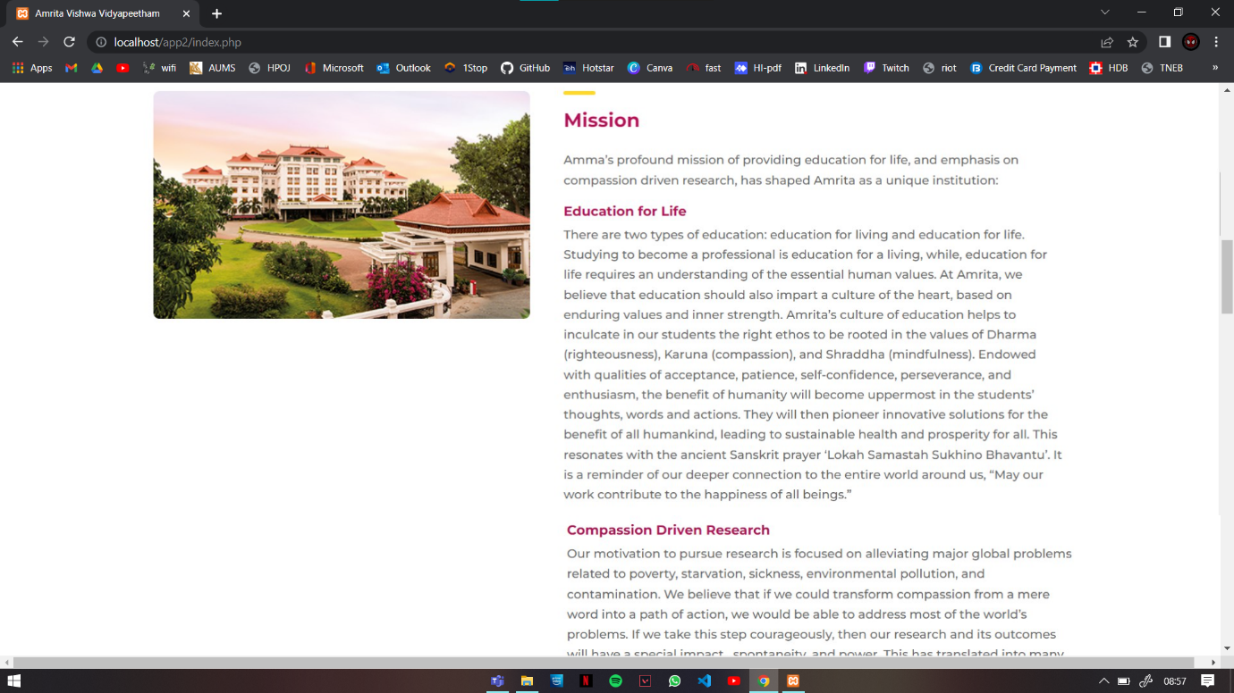

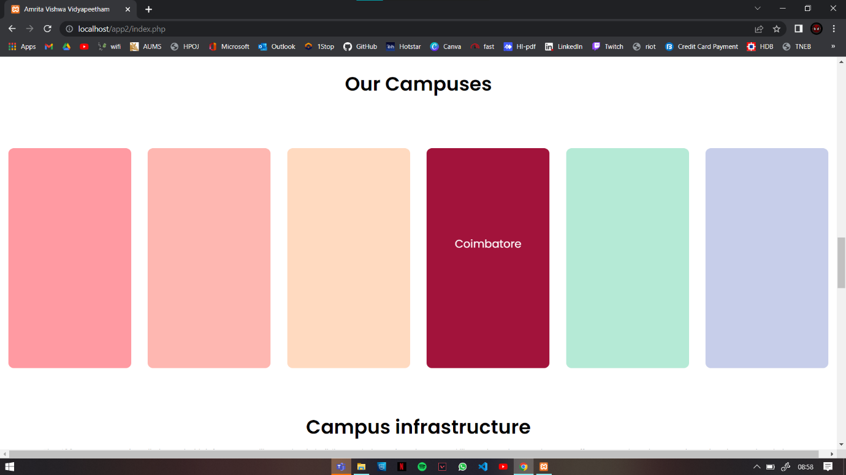

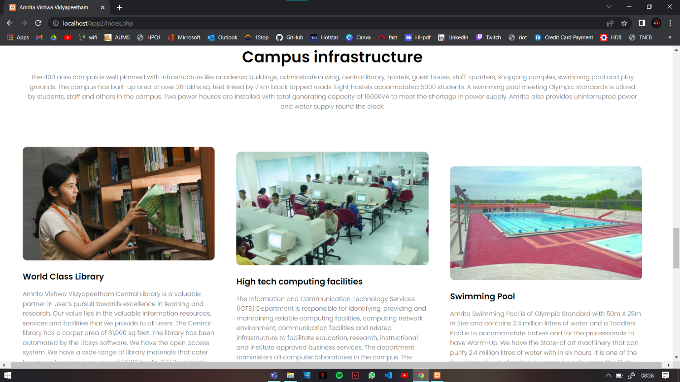

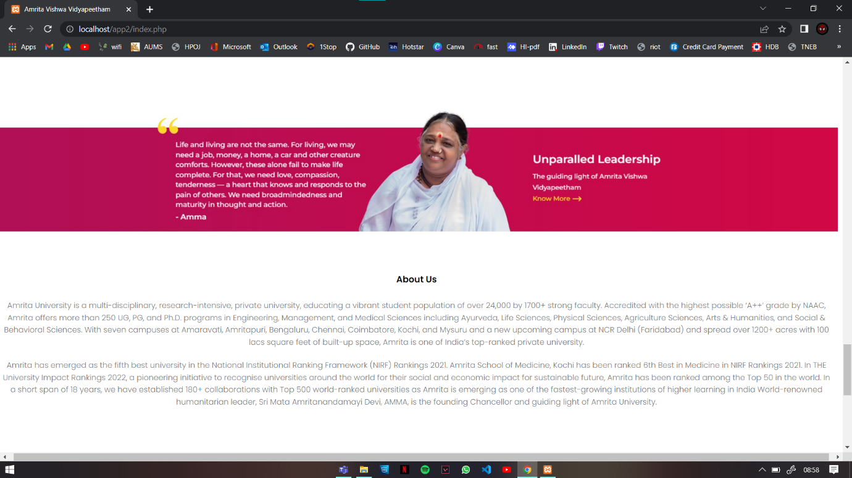

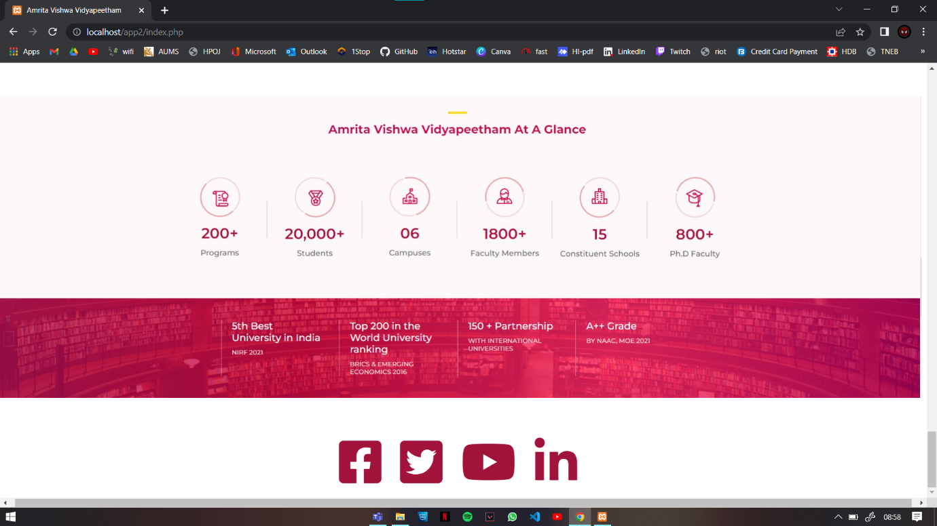

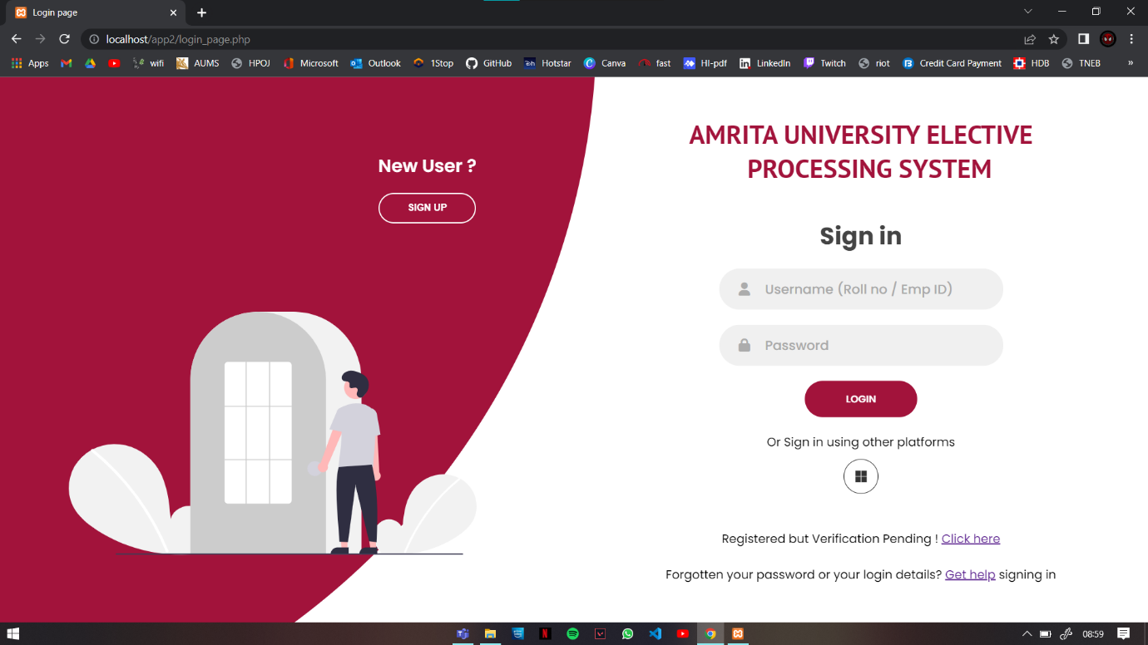

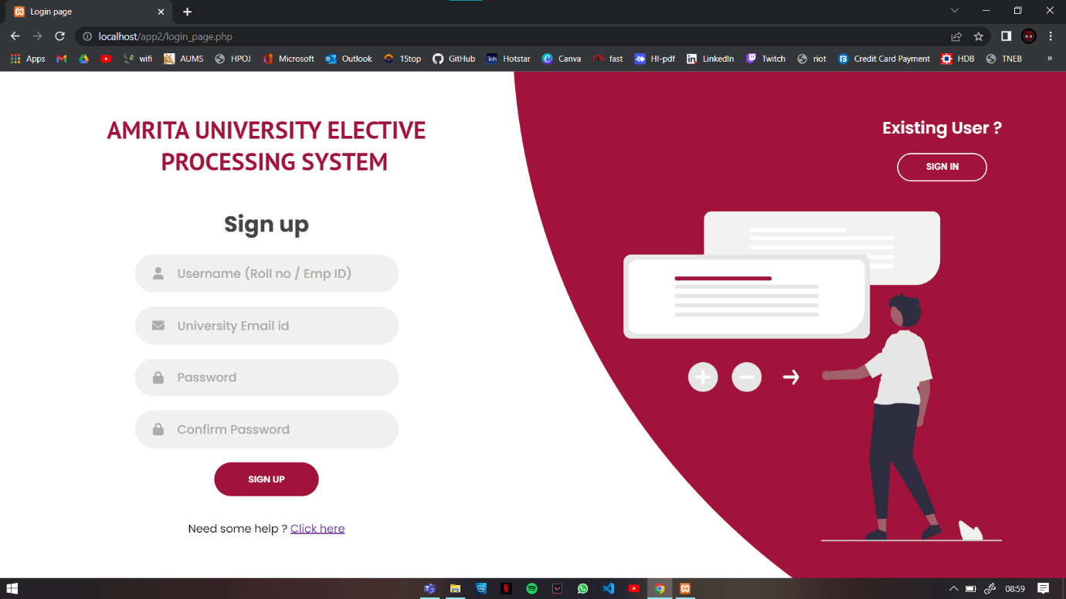

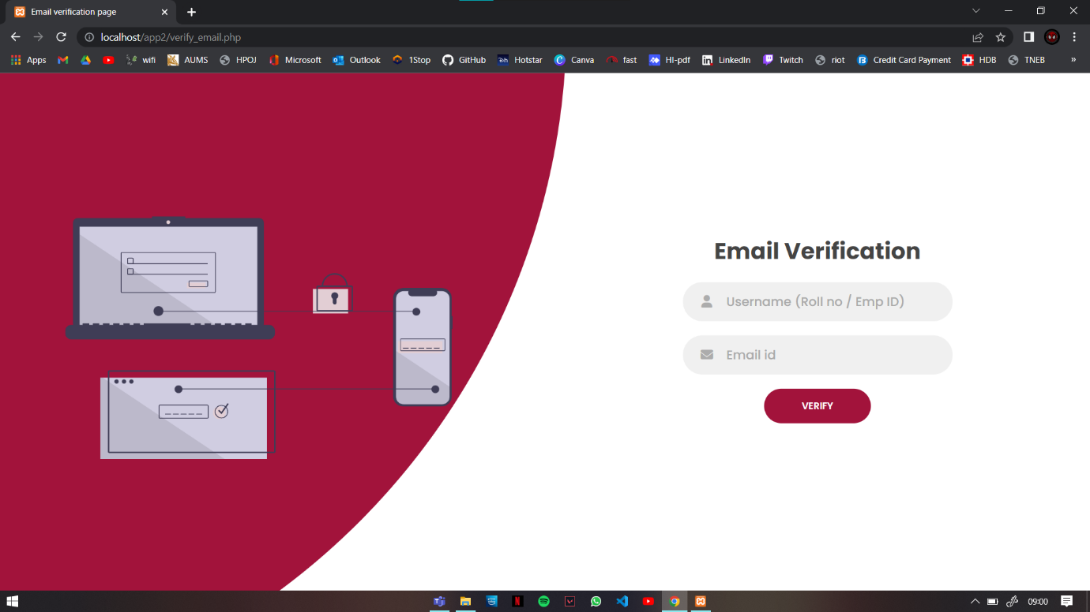

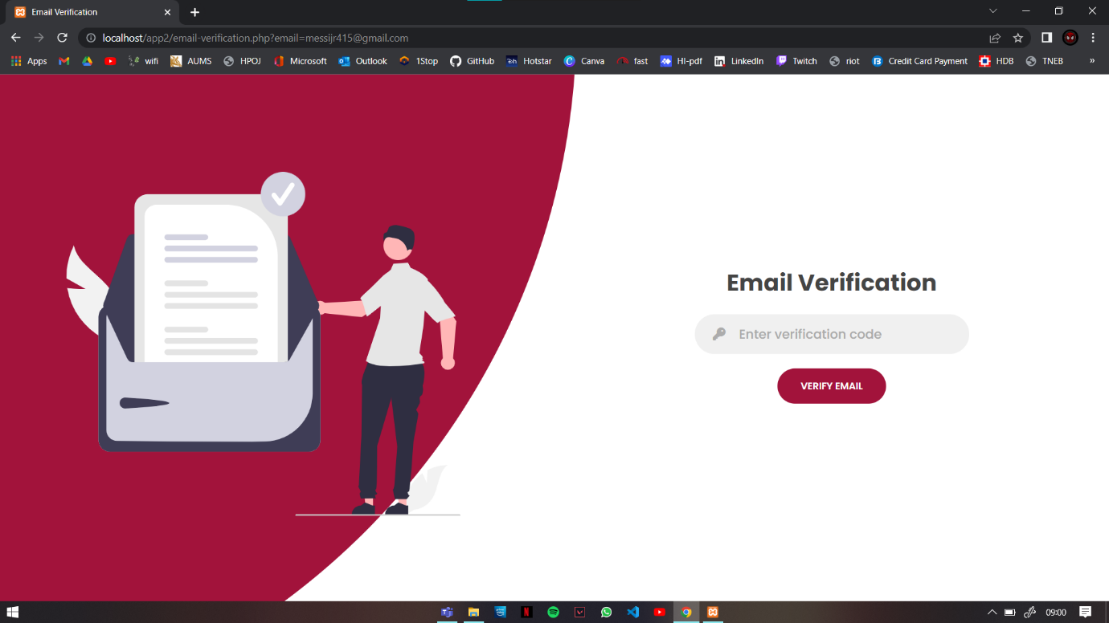

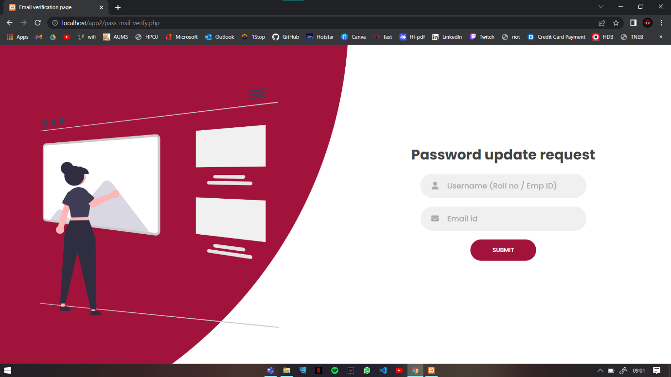

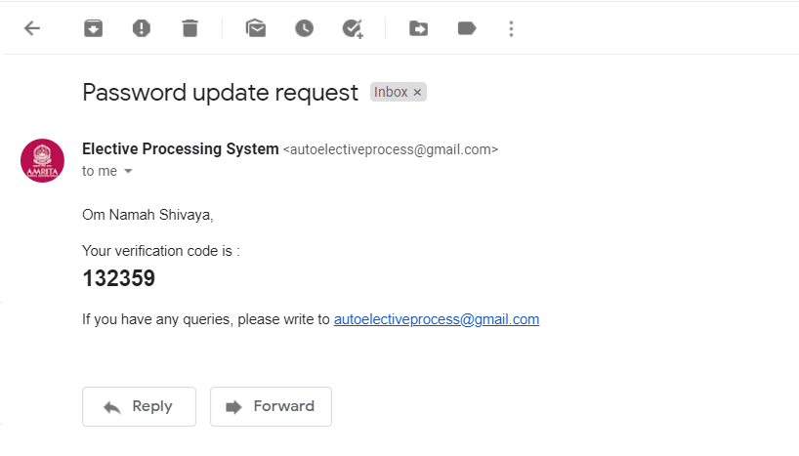

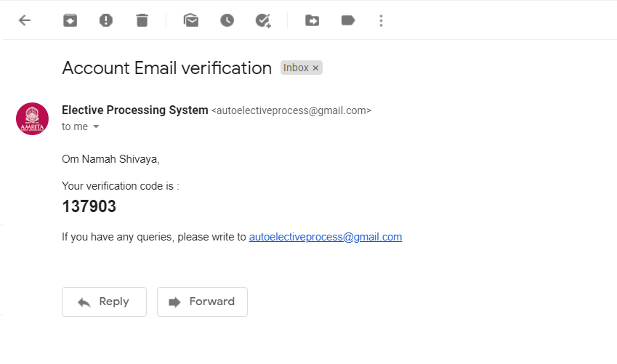

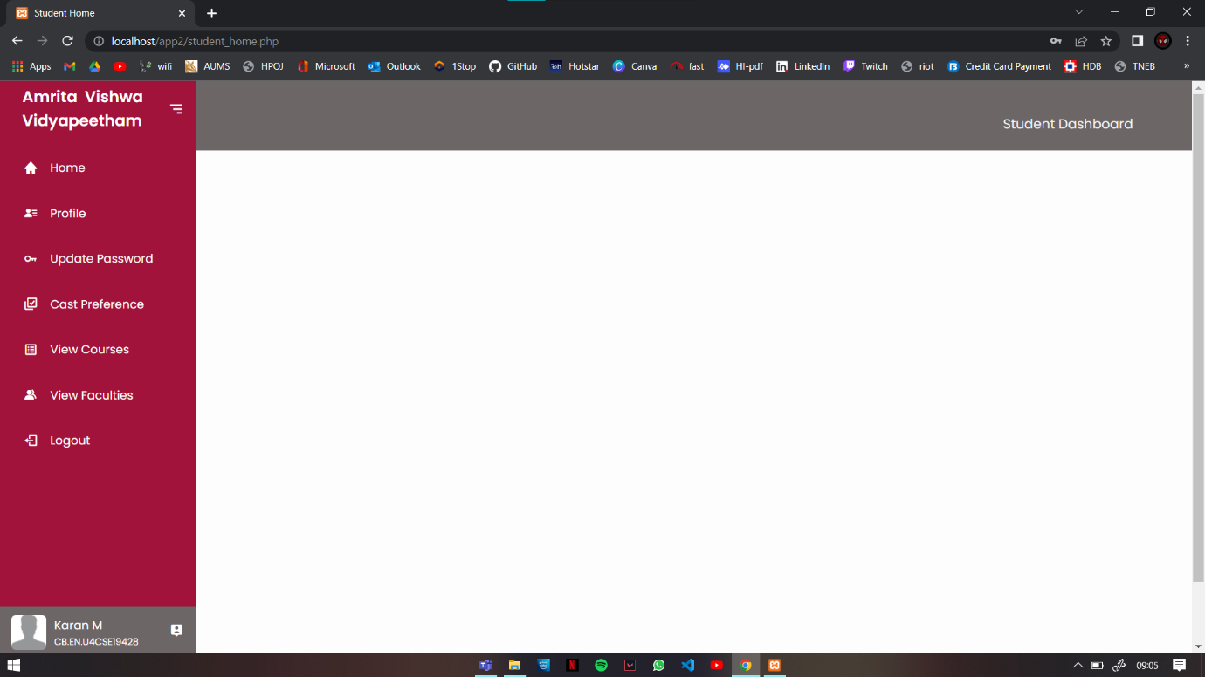

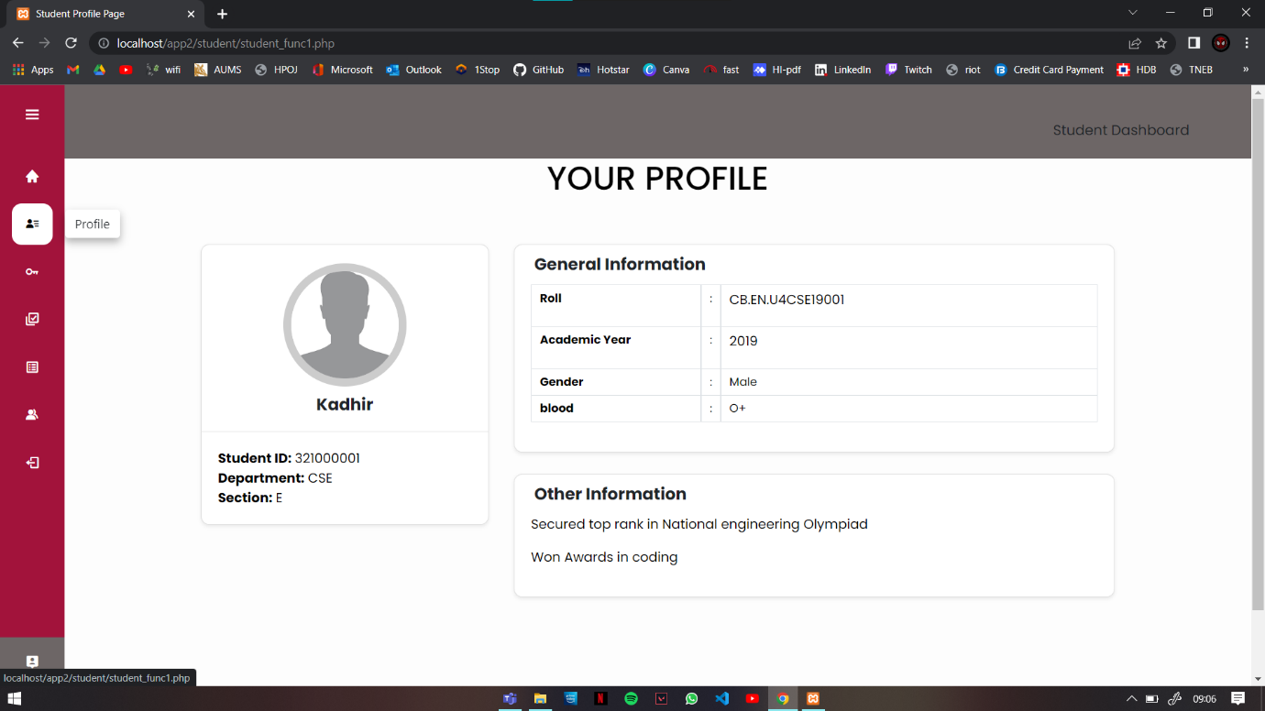

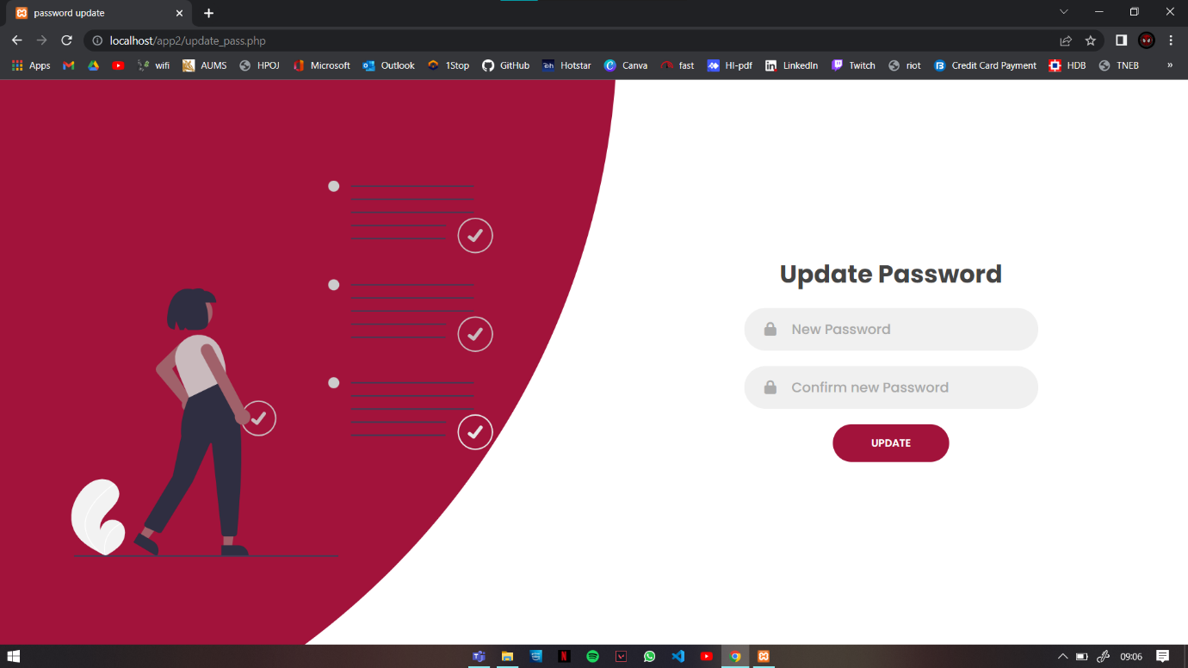

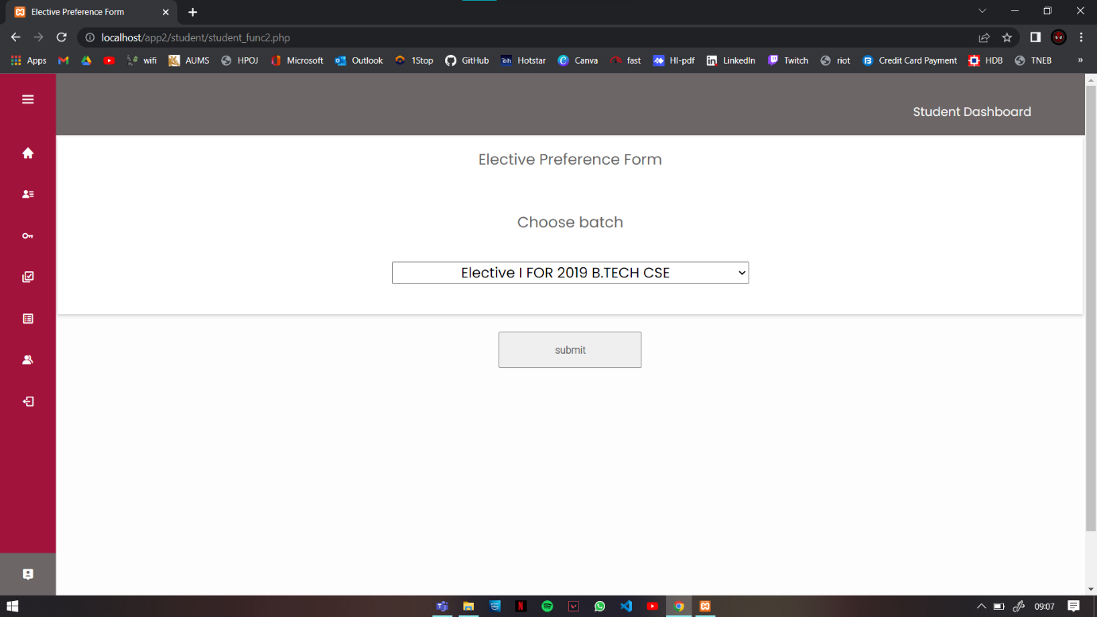

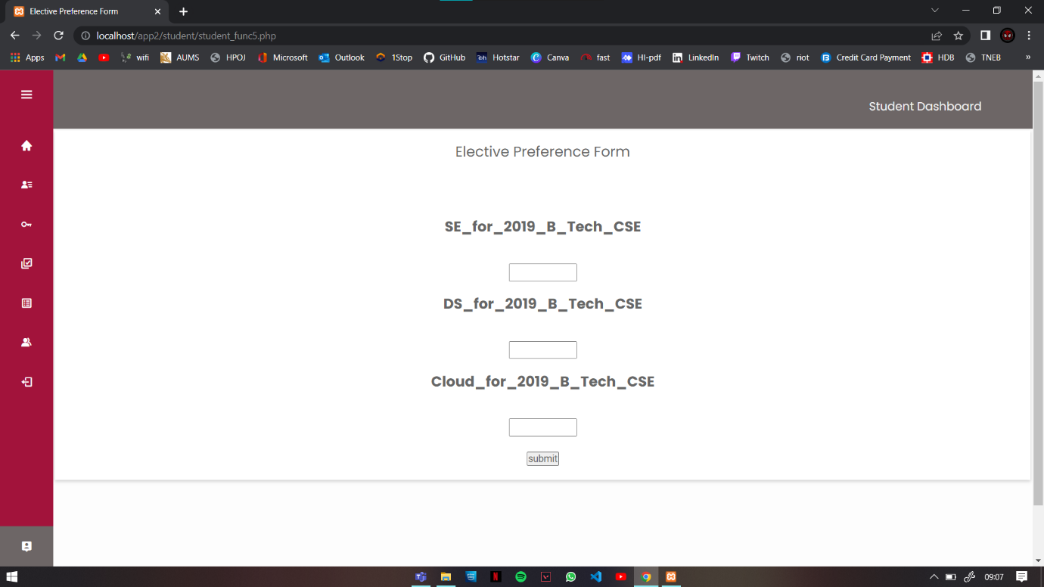

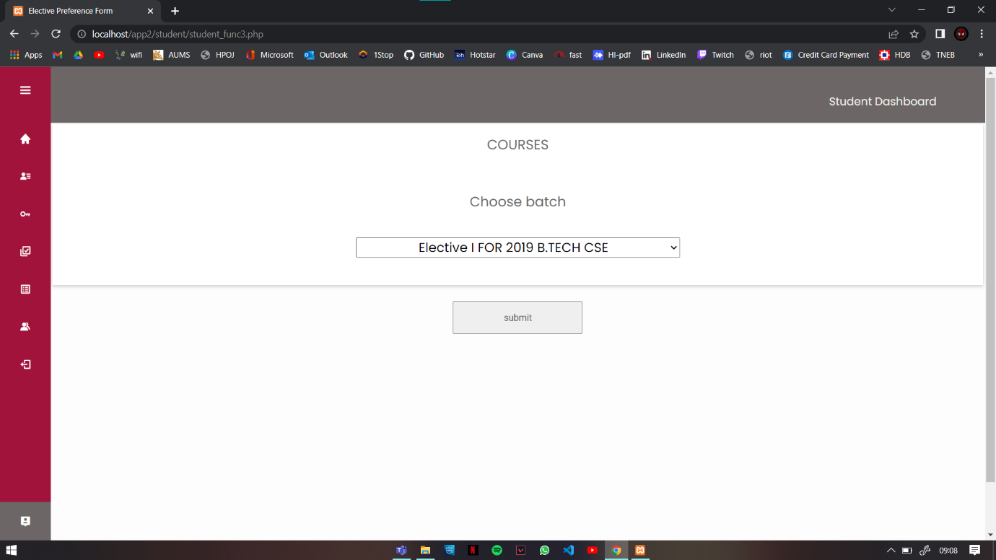

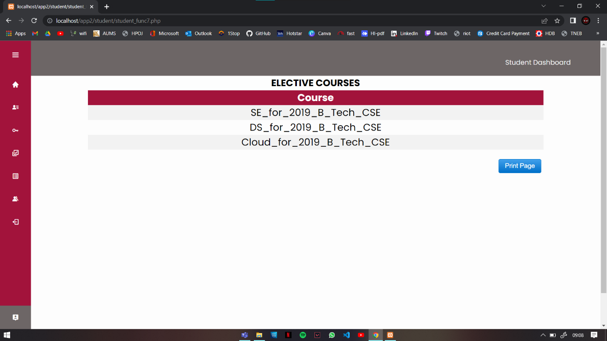

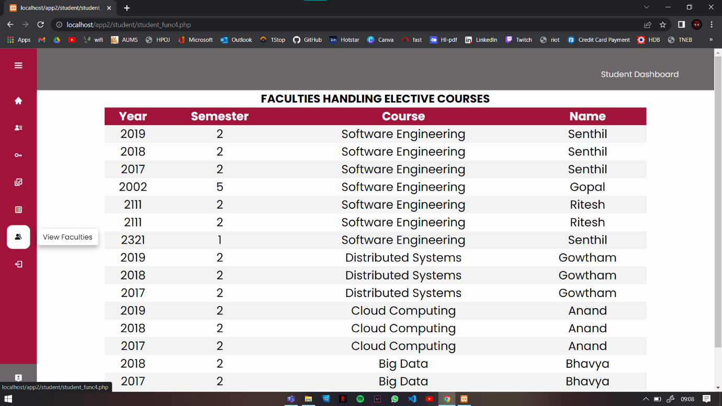



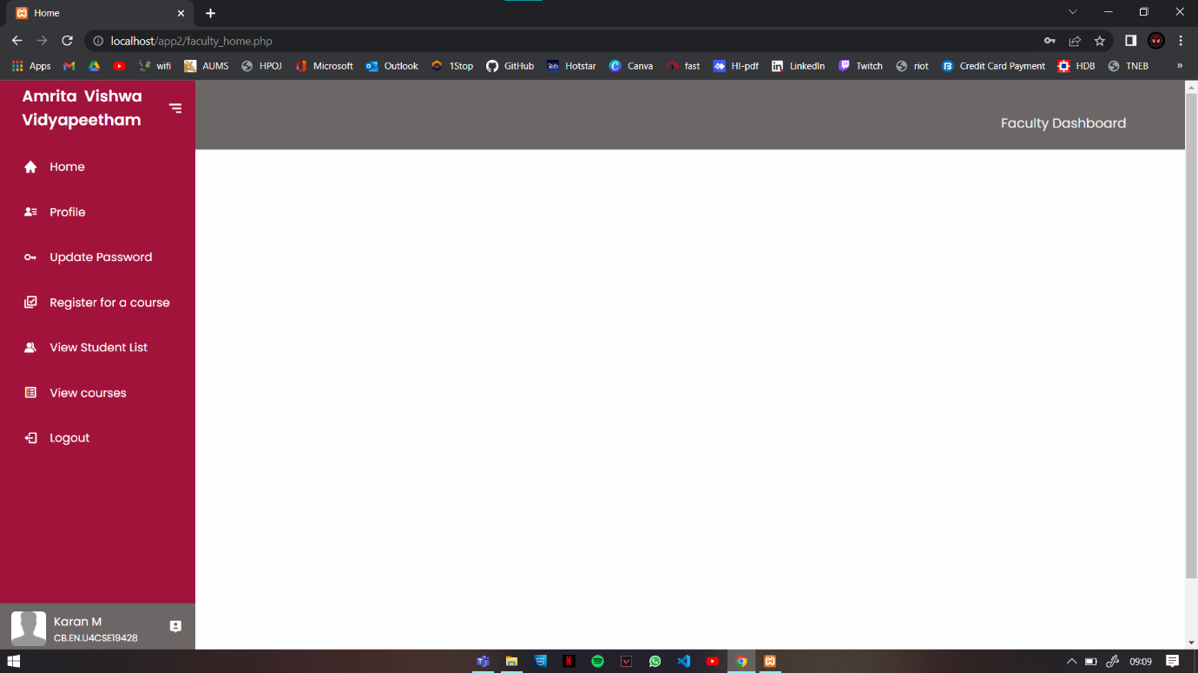

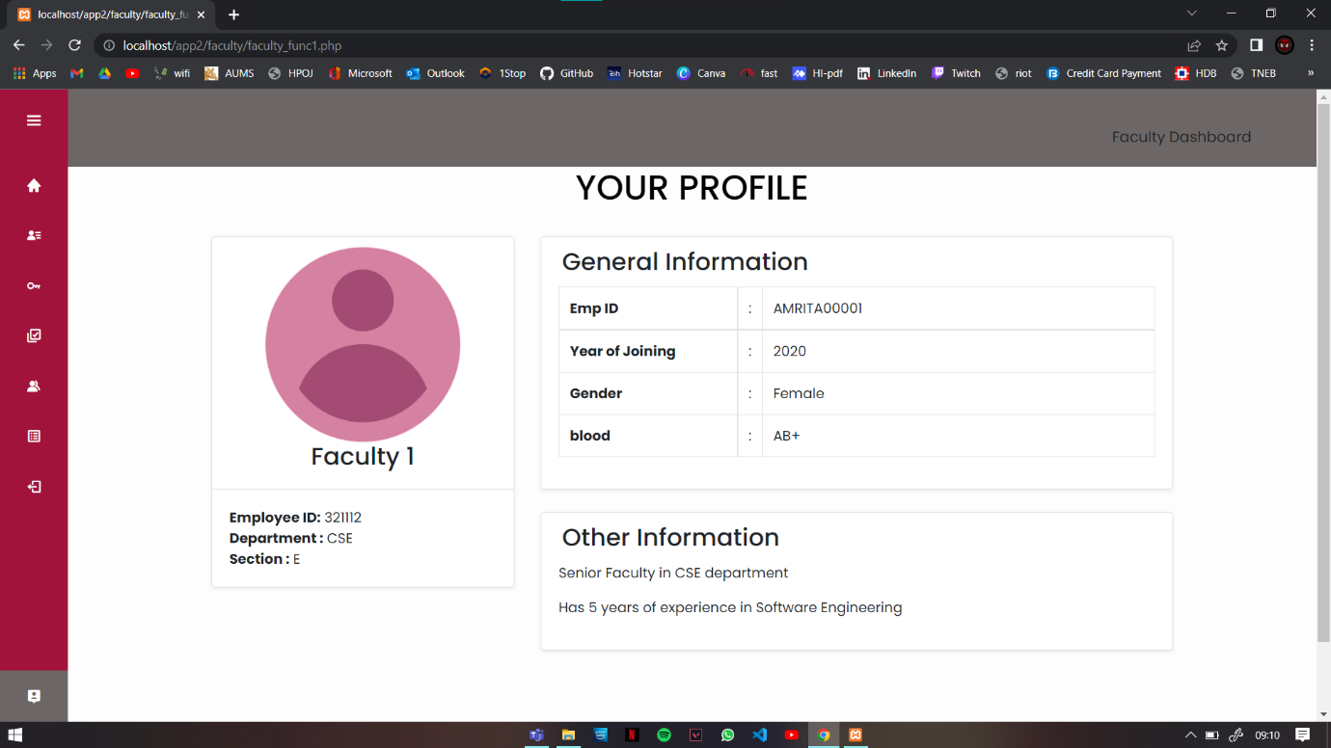

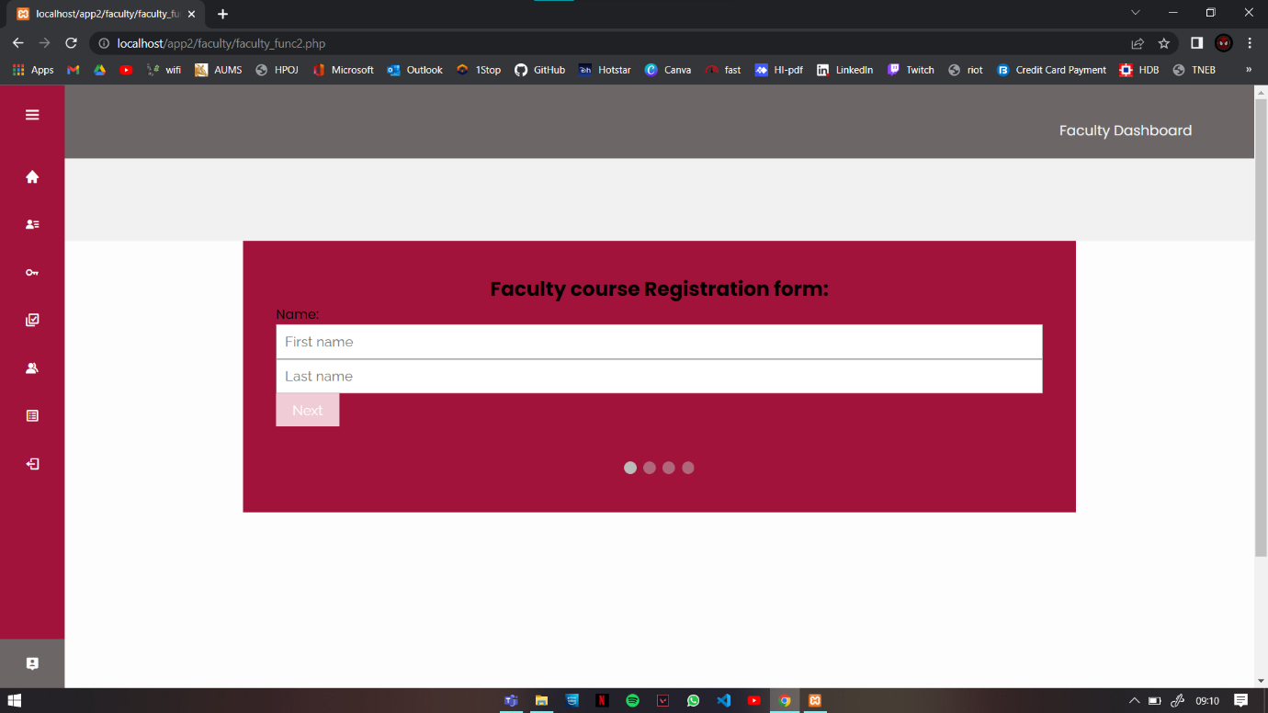

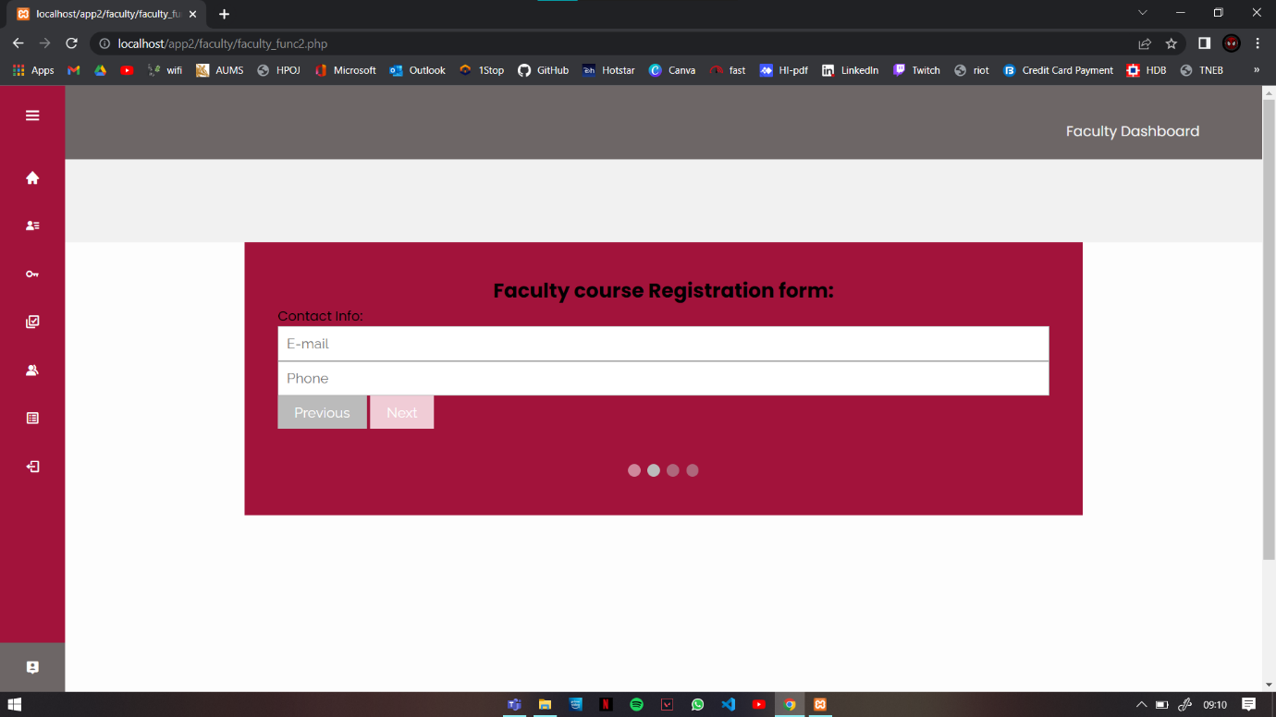

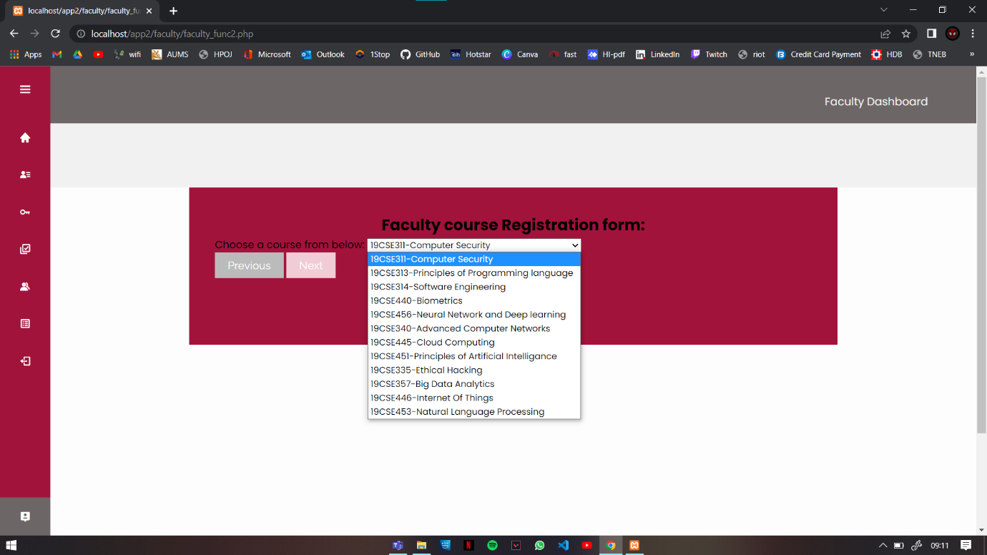

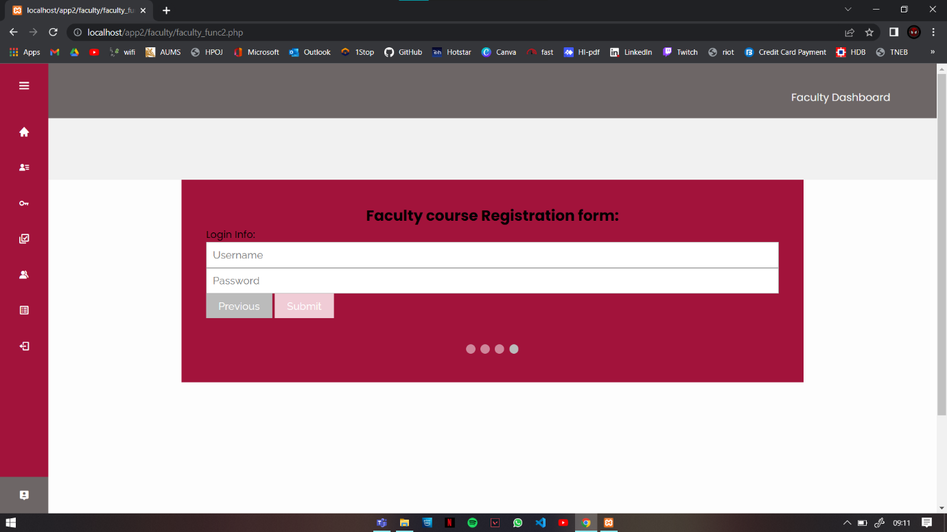

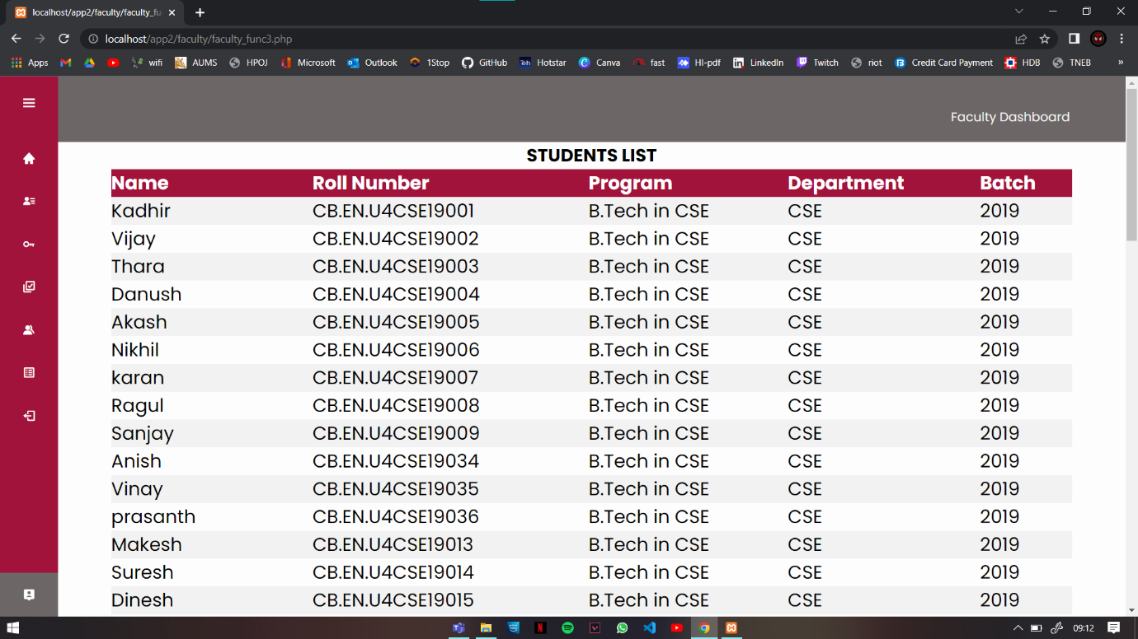

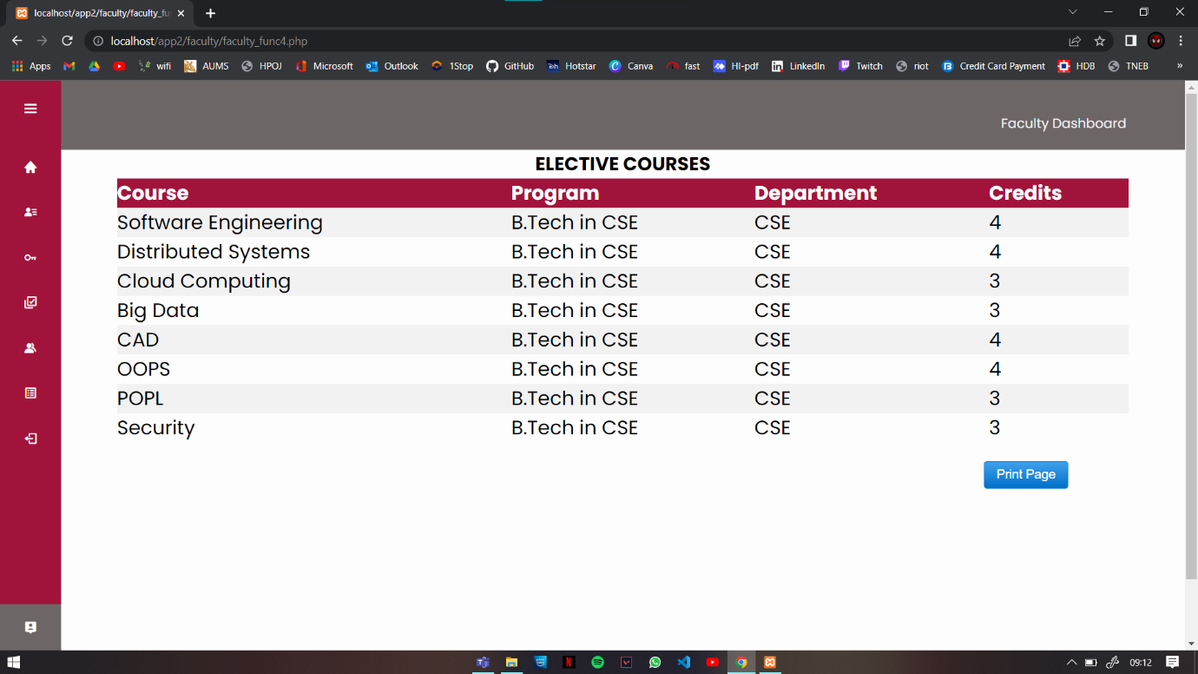

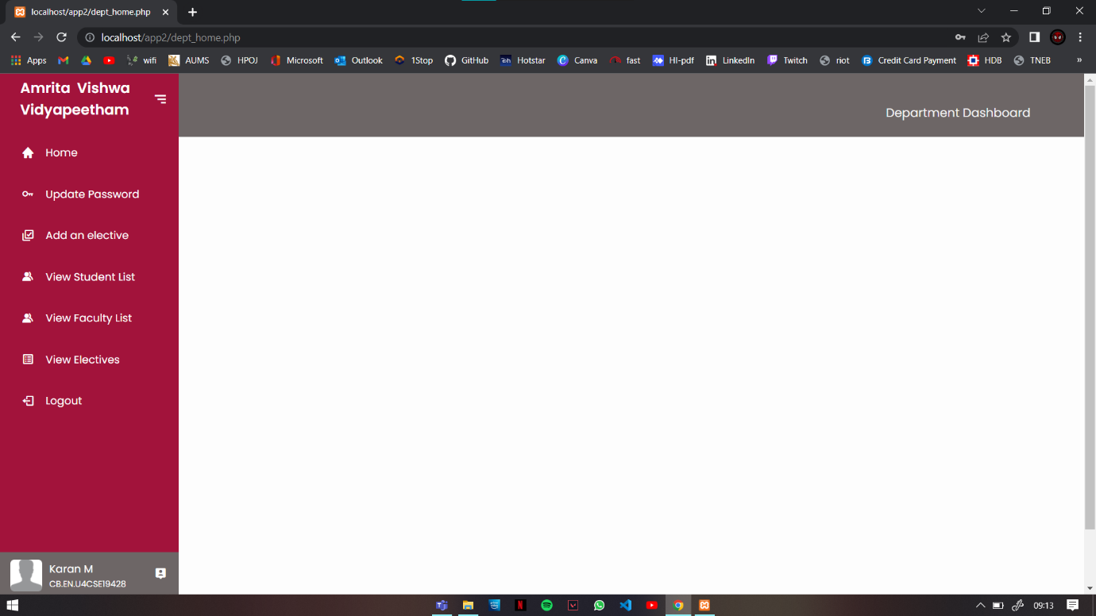

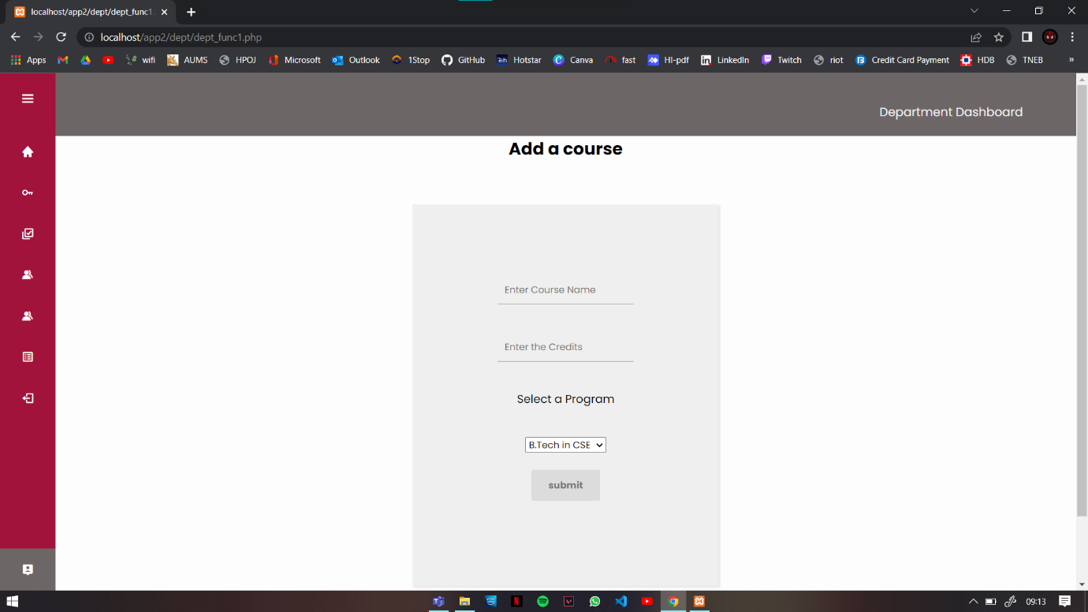

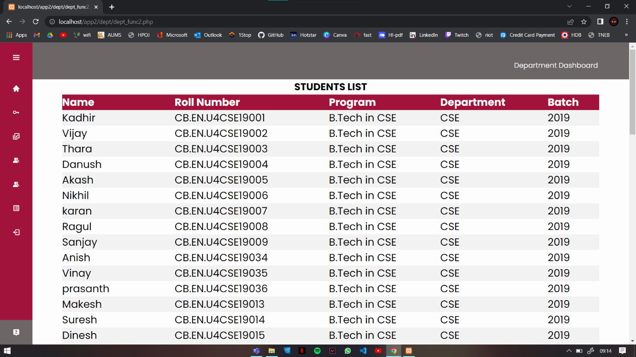

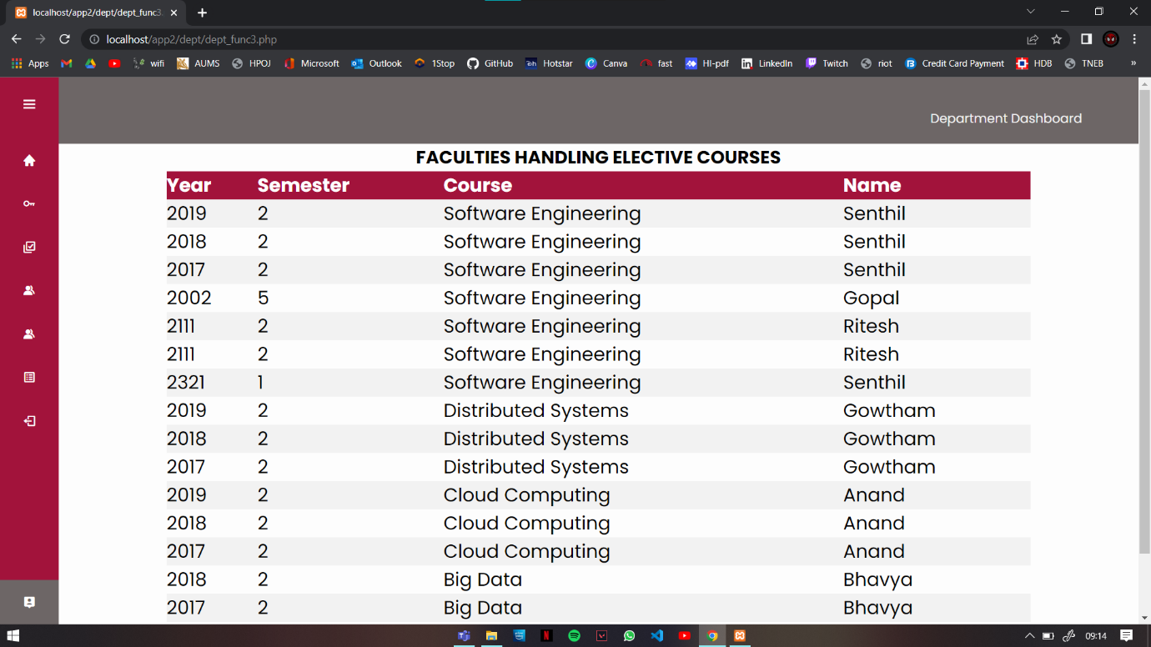

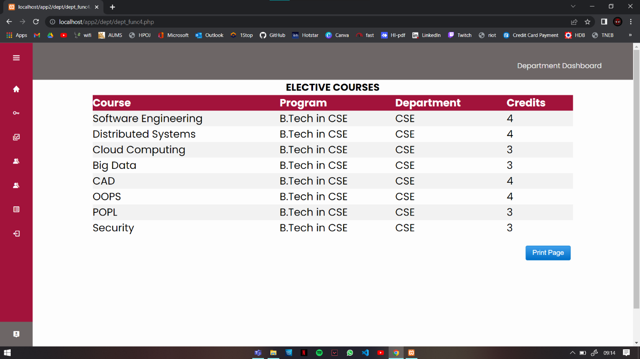

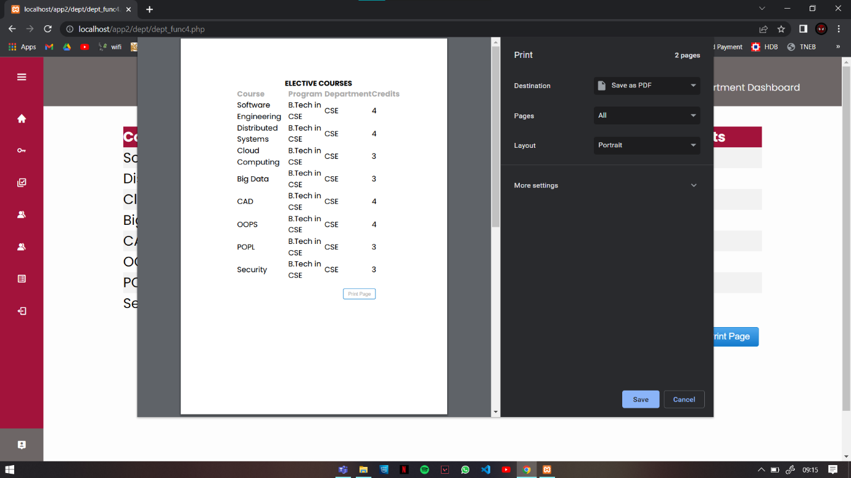

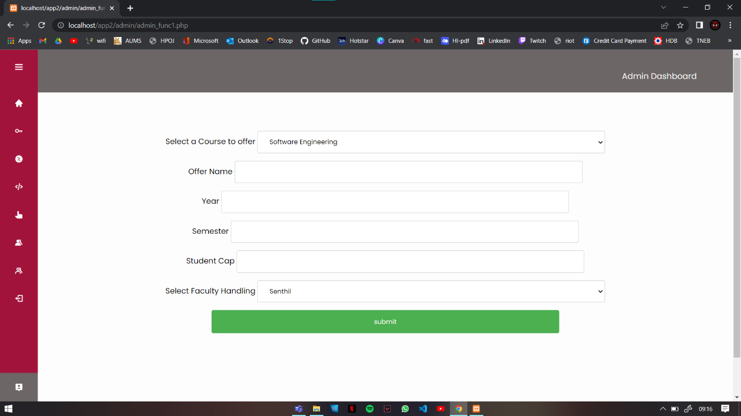

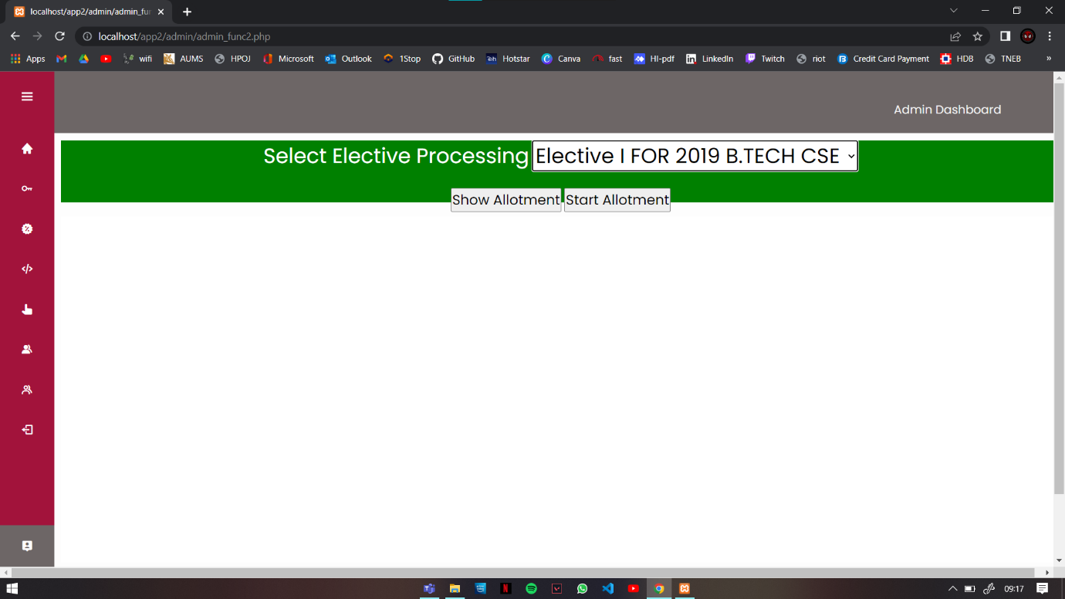

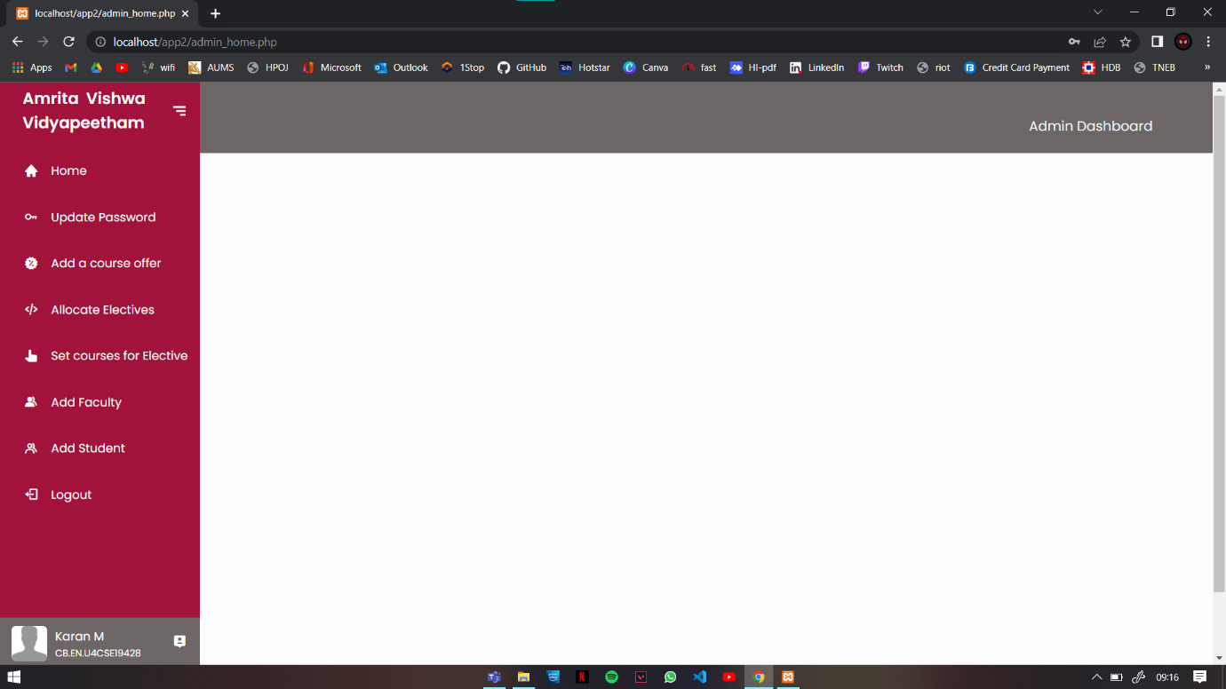

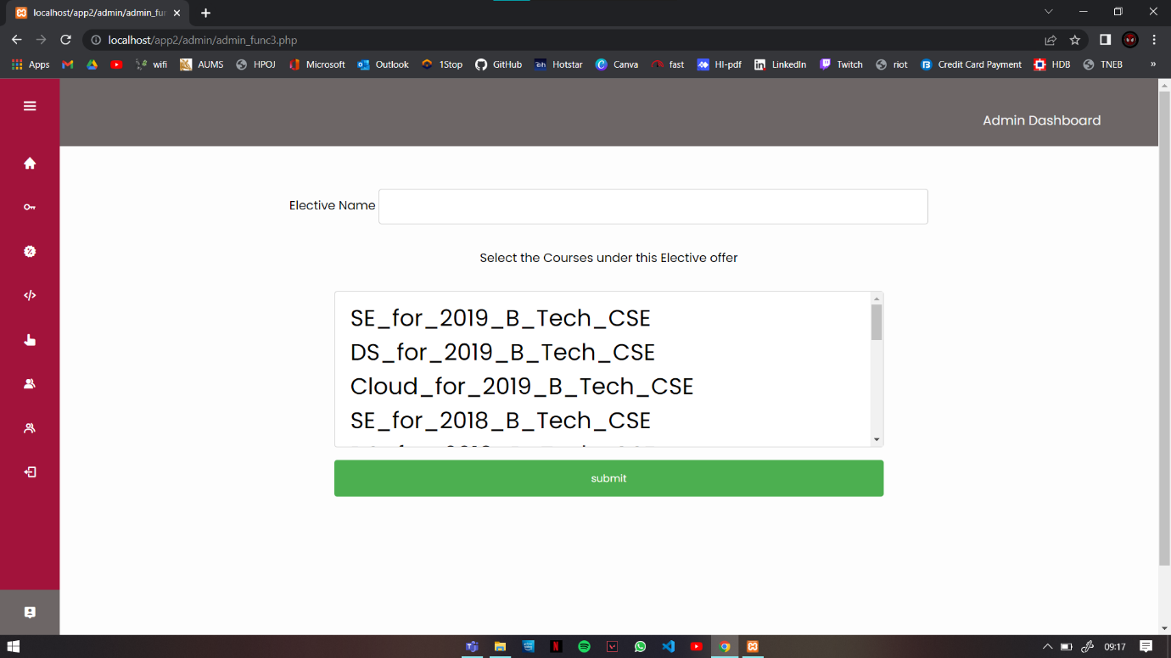

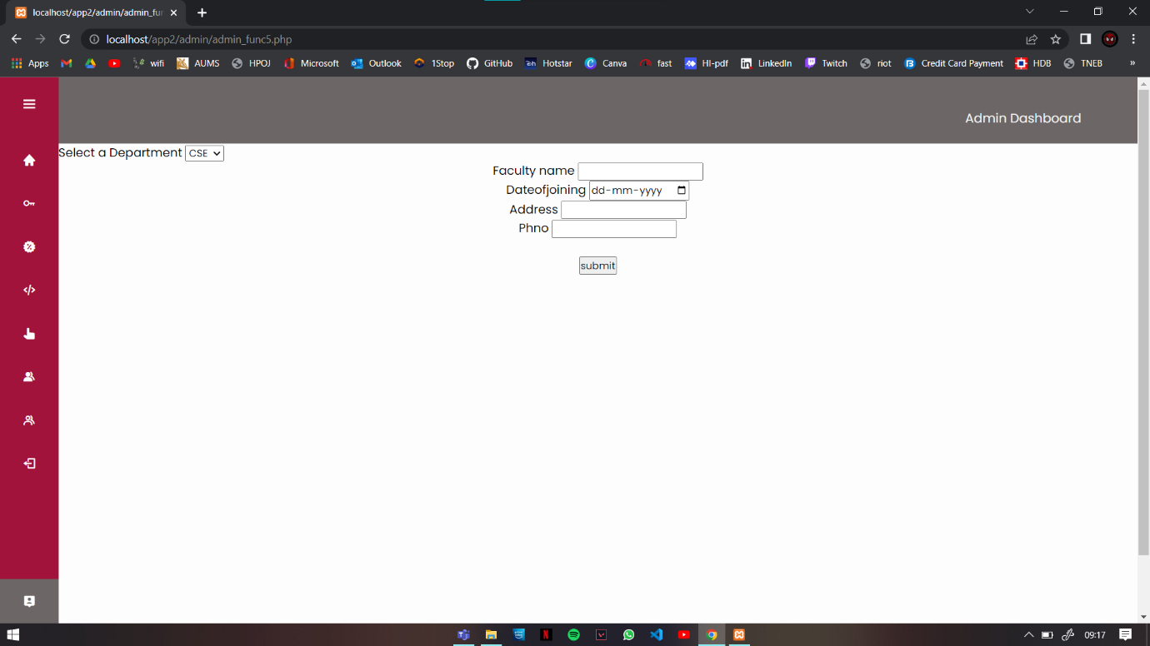

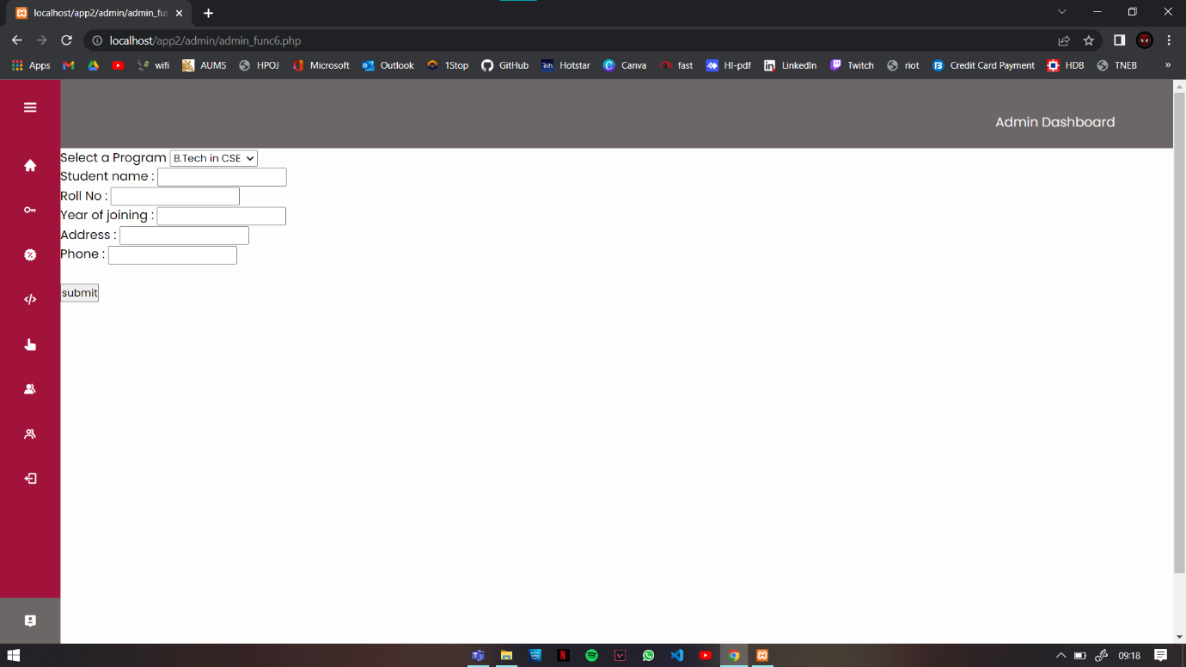

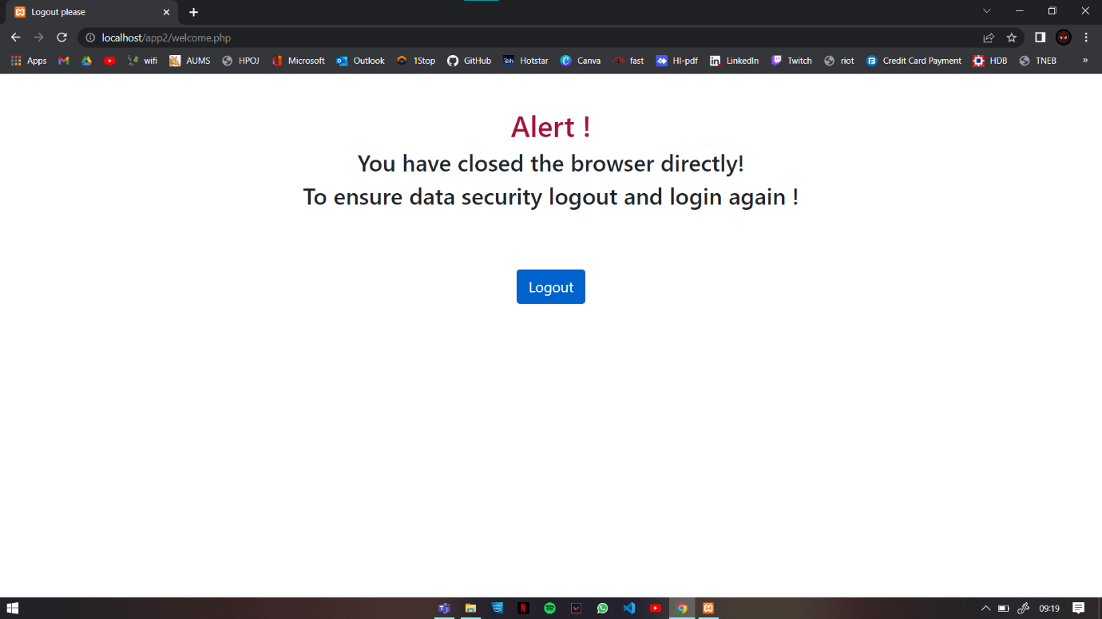

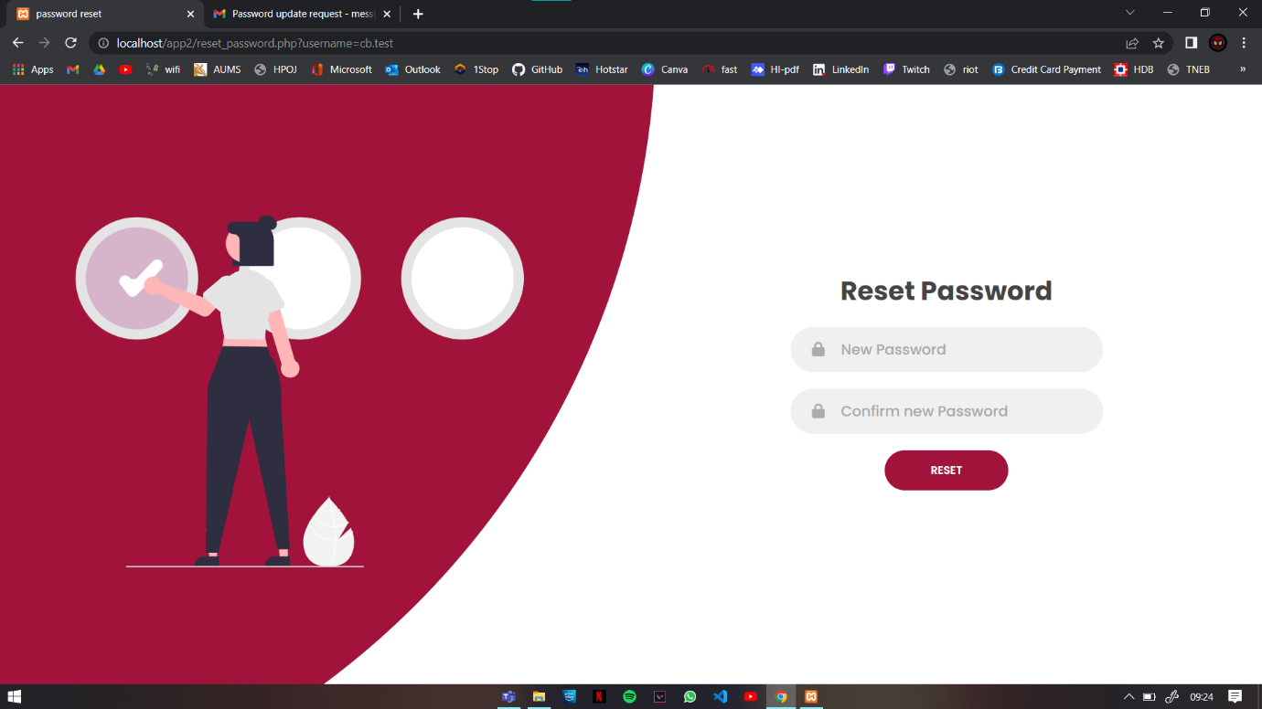

**10. Conclusion**

The aim of this project was to develop a website that helps the admin, students and faculty to administer/manage the elective processing automatically.

As amrita being one of the biggest institutions, looking into the

number of electives that are being conducted, their details, the schedule, the faculty who is assigned to the certain elective and

management tasks that come with it are tedious and hectic so a

software that can ease out this job for the faculty and the admin is

always in need and this software will now ease out the job of both

admin, faculty and students.